Shop Savvy

SPROJ Report



### **Ahmad Kashif Jabbar – 25100002**

### **Husnain Ali – 25100105**

### **Musa Aftab Ahmed – 25100179**

### **Syed Messam Ali – 25100229**

### **Zainab Fatima – 25100208**

Advisor:   
School of Science and Engineering  
Lahore University of Management Sciences  
28th April 2025

**Acknowledgement and Dedication**

**Certificate**

I certify that the senior project titled “**Shop Savvy”** was completed under my supervision by the following students:

### **Ahmad Kashif Jabbar – 25100002**

### **Husnain Ali – 25100105**

### **Musa Aftab Ahmed – 25100179**

### **Syed Messam Ali – 25100229**

### **Zainab Fatima – 25100208**

and the project deliverables meet the requirements of the program.

------------------------------------- Date:

**Advisor (Signature)**

------------------------------------- Date:

**Co-advisor (if any)**

# Table of Contents

# List of Figures

# Introduction

**Introduction**

Shop Savvy is an AI-driven personalized clothing recommendation platform developed specifically for the Pakistani online retail market. The application aggregates fashion products from various local clothing brands, providing a centralized, user-friendly shopping experience. It operates primarily in the domain of fashion e-commerce, integrating advanced technological solutions to simplify and personalize online shopping.

The primary target users of Shop Savvy are online consumers in Pakistan who shop for clothing items. The platform specifically caters to individuals who prefer personalized recommendations and efficient product discovery. By combining AI-driven recommendations with conversational chatbot support, Shop Savvy meets the demands of tech-savvy shoppers seeking intelligent, user-centric online shopping experiences.

The product developed is a responsive web application built on the MERN (MongoDB, Express, React, Node.js) technology stack. This ensures accessibility and usability across various devices and browsers, delivering a seamless user interface enriched with dynamic content.

**b. Objective and Scope**

The primary objective of Shop Savvy is to significantly enhance the online shopping experience for Pakistani consumers by addressing existing inefficiencies and providing tailored recommendations. Specifically, the application aims to:

* Aggregate fashion products from multiple Pakistani clothing brands through automated web scraping techniques.
* Develop an intuitive and responsive web application employing the MERN stack to ensure robust, scalable performance.
* Implement a real-time AI-based recommendation engine that personalizes product suggestions based on user interactions such as product clicks, search filters, wishlist activities, and browsing history.
* Integrate an LLM-powered chatbot to assist users in discovering relevant products, handling queries, and providing an interactive shopping experience.
* Deliver a cohesive and engaging user interface with functionalities such as product viewing, advanced filtering, redirection to brand-specific product pages, secure user login/signup, and wishlist management.

By achieving these objectives, Shop Savvy aims to transform business operations within the Pakistani fashion e-commerce domain, streamlining product discovery, increasing user engagement, and potentially driving sales through improved personalization and customer satisfaction.

**c. Development Methodology**

Shop Savvy was developed using the Agile Scrum methodology due to its suitability for dynamic and evolving project requirements. Agile Scrum enabled incremental development and iterative feedback cycles, facilitating the integration of complex AI models, dynamic API integrations, and evolving user interface components. Regular sprints and continuous user feedback were fundamental in refining the platform features and ensuring the delivery of high-quality, user-centric functionalities in a timely and efficient manner.

**d. Contributions**

Shop Savvy presents several notable contributions and innovations to the local fashion e-commerce domain:

* **Centralized Product Aggregation**: Unlike typical isolated brand websites, Shop Savvy aggregates products from numerous local brands onto a single unified platform, dramatically reducing the time and effort required for consumers to find desired products.
* **Advanced Personalization**: The implementation of a sophisticated AI-driven recommendation engine significantly enhances product discovery, tailoring suggestions based on individual user preferences and historical interactions.
* **Conversational Commerce**: The integration of an LLM-powered chatbot delivers intelligent, real-time conversational support, elevating the user experience through natural language interactions and proactive assistance.
* **Enhanced User Experience**: With a clean, responsive design built using modern web technologies, Shop Savvy offers intuitive navigation, interactive elements, and seamless redirection capabilities, surpassing existing local platforms in terms of usability and engagement.

Overall, Shop Savvy’s integration of AI technology, advanced personalization, and superior user experience positions it as a pioneering solution that significantly advances the capabilities of online fashion shopping within Pakistan, surpassing current market offerings.

# System Requirements

Brief introduction of this chapter in a paragraph highlighting the content

## System Actors

List down the actor names and give a 2-3 lines description of the role of each actor

|  |  |
| --- | --- |
| **Actor Name** | **Description** |
| End User (Shopper) | The primary actor, the shopper, interacts with the virtual shopping assistant to browse, search, and receive personalized product recommendations. They provide inputs through queries, wish lists, and purchase history, enabling the system to tailor suggestions based on their preferences. |
| E-commerce Platforms | These represent local and international shopping brands that the assistant connects with. The platforms provide links to their product pages, along with details like descriptions, prices, and availability. |
| Recommendation Engine (AI Module) | This backend actor processes user data (product clicks, time spent on product, filters, wishlists) to generate tailored suggestions. It leverages NLP models, vector similarity matching, and to output the most relevant product recommendations |
| System Administrator | This actor manages the backend of the virtual shopping assistant. They oversee product database updates, monitor chatbot performance, handle user feedback, and ensure integrations with e-commerce platforms remain functional. They may also trigger retraining of recommendation models or update system configurations. |

## Functional Requirements

List down system requirements. You may group requirements according to actors or modules

|  |  |
| --- | --- |
| **Requirements** | |
| **Sr#** | **End User (Shopper) Requirement** |
| 1 | **As an end user,** I want to be able to create an account with my email or social media profiles. |
| 2 | **As an end user,** I want to be able to log into my account. |
| 3 | **As an end user,** I want to be able to update my personal information, preferences, and shopping history in my profile. |
| 4 | **As an end user,** I want the system to suggest personalized product recommendations based on my preferences and past purchases. |
| 5 | **As an end user,** I want to search for products using natural language queries (e.g., “Show me affordable jeans”). |
| 6 | **As an end user,** I want the system to filter products based on criteria like price, brand, and category (e.g.,T-Shirt, Trousers). |
| 7 | **As an end user,** I want the system to notify me of promotions, sales, or discounts on products I’ve browsed or shown interest in. |
| 8 | **As an end user,** I want to receive personalized notifications for new arrivals or restocked items based on my previous interactions. |
| 9 | **As an end user,** I want to be able to like or dislike, so the system can refine future recommendations. |
| 10 | **As an end user,** I want to receive real-time updates on product availability and stock levels from e-commerce platforms. |
| 11 | **As an end user,** I want the system to provide style advice and recommend trending products relevant to my preferences. |
| 12 | **As an end user,** I want to be able to save products to a wishlist for future reference. |
| 13 | **As an end user,** I want to be able to track my purchase history through the platform. |
| 14 | **As an end user,** I want to compare similar products from different platforms based on price, availability, material used, style etc. before making a purchase decision. [Optional] |
| 15 | **As an end user,** I want to share product recommendations or my wishlist with friends via social media or messaging apps. |

|  |  |
| --- | --- |
|  | **E-commerce Platform Integration Requirement** |
| 16 | **As an e-commerce platform,** I want the system to retrieve product data like descriptions, reviews, prices, and availability through APIs or web scraping. |
| 17 | **As an e-commerce platform,** I want the system to display accurate and updated product details in real-time to users. |
| 18 | **As an e-commerce platform,** I want the system to allow seamless integration of promotional campaigns and deals for products. |
| 19 | **As an e-commerce platform,** I want the system to provide redirection links to product pages, where users can complete purchases. |
| 20 | **As an e-commerce platform,** I want the system to generate user behavior analytics reports, helping us understand purchasing patterns and optimize our offerings. |
| 21 | **As an e-commerce platform,** I want the system to aggregate data from multiple platforms to provide similar products’ comparison, allowing users to compare them based on price, material quality, style, etc. [Optional] |

|  |  |
| --- | --- |
|  | **Recommendation Engine (AI Module)** |
| 22 | **As a recommendation engine**, I want to analyze user queries, wish lists, product clicks, categories selected, filters to identify key preferences and fashion intent. |
| 23 | **As a recommendation engine**, I want to generate product suggestions using semantic similarity between user input and product embeddings. |
| 24 | **As a recommendation engine**, I want to rank recommended products based on relevance, popularity, and personalization score. |
| 25 | **As a recommendation engine**, I want to continuously learn from user interactions and feedback to improve recommendation accuracy over time. |
| 26 | **As a recommendation engine**, I want to filter out unavailable or out-of-stock products from recommendations. |
| 27 | **As a recommendation engine**, I want to support multi-modal inputs (e.g., text, image uploads) for richer recommendation generation. [Optional] |
| 28 | **As a recommendation engine**, I want to ensure low-latency response times to enable real-time interaction with the shopping assistant. |

|  |  |
| --- | --- |
|  | **System Administrator** |
| 22 | **As a system administrator**, I want to manage the database of products, including adding, editing, or removing items manually. |
| 23 | **As a system administrator**, I want to monitor chatbot performance and system uptime through a centralized dashboard. |
| 24 | **As a system administrator**, I want to view and analyze user behavior and engagement metrics to make data-driven decisions. |
| 25 | **As a system administrator**, I want to configure API keys, endpoints, and scraping logic for connected e-commerce platforms. |
| 26 | **As a system administrator**, I want to review flagged content or errors in chatbot conversations to ensure quality. |
| 27 | **As a system administrator**, I want to trigger retraining or updating of recommendation models when new data becomes available. |
| 28 | **As a system administrator**, I want to control promotional banners or featured products that appear in the user interface. |

## Non-functional Requirements

List down non-functional requirements.

|  |  |
| --- | --- |
| **Sr#** | **Requirements** |
| 1 | **Scalability:**   1. The system must be capable of handling at least 10,000 concurrent user interactions without degradation in performance. |
| 2 | **Response Time:**   1. The system should provide product recommendations within 2 seconds of receiving a user query. |
| 3 | **Data Storage:**   1. The system should be able to store and manage up to 1 TB of user and product data without performance impact. |
| 4 | **System Availability:**   1. The system must maintain 99.9% uptime, with scheduled maintenance windows not exceeding 1 hour per month. |
| 5 | **Error Handling:**   1. The system should have automated error logging and alerting mechanisms, and errors should be logged with a severity level and timestamp for analysis. |
| 6 | **Security:**   1. All user data must be encrypted using at least AES-256 encryption both at rest and in transit. |
| 7 | **Compliance:**   1. The system should comply with GDPR and CCPA regulations for data privacy and user consent. |
| 8 | **Integration Latency:**   1. The real-time integration with e-commerce platforms should have a latency of no more than 1 second for updating product availability and prices. |
| 9       10 | **Model Accuracy:**   1. The recommendation engine should achieve a precision score of at least 80% in product suggestions based on user interactions.         **NLP Accuracy:** 2. The NLP model should achieve an F1 score of at least 75% in understanding and processing user queries. |
| 11 | **User Interface Performance:**   1. The web application should load within 3 seconds on standard broadband connections. |
| 12 | **Data Update Frequency:**   1. The product data and trend information should be updated at least once every hour to reflect the latest information. |
| 13 | **Backup and Recovery:**   1. The system should perform automated backups every 24 hours and be able to restore to the last backup point within 30 minutes of a data loss incident. |
| 14        15 | **User Interaction Limits:**   1. The system should be capable of handling up to 1 million user queries and interactions per day.    **Resource Utilization:** 2. The application servers should not exceed 75% CPU utilization under peak load conditions. |
| 16 | **Compatibility:**   1. **Requirement:** The web application must be compatible with the latest versions of Chrome, Firefox, Safari, and Edge. |
| 17 | **Data Handling Capacity:**   1. Requirement: The system must be able to handle a minimum of 100,000 data transactions per hour without performance degradation. |
| 18 | **Load Distribution:**   1. Requirement: The load balancer should evenly distribute incoming requests across at least three application servers. |
| 19 | **High Availability:**   1. Requirement: The system must maintain high availability with no more than 5 minutes of downtime during a load balancer failure. |

# System Architecture

## Architecture Diagram

Draw a diagram of the system architecture.

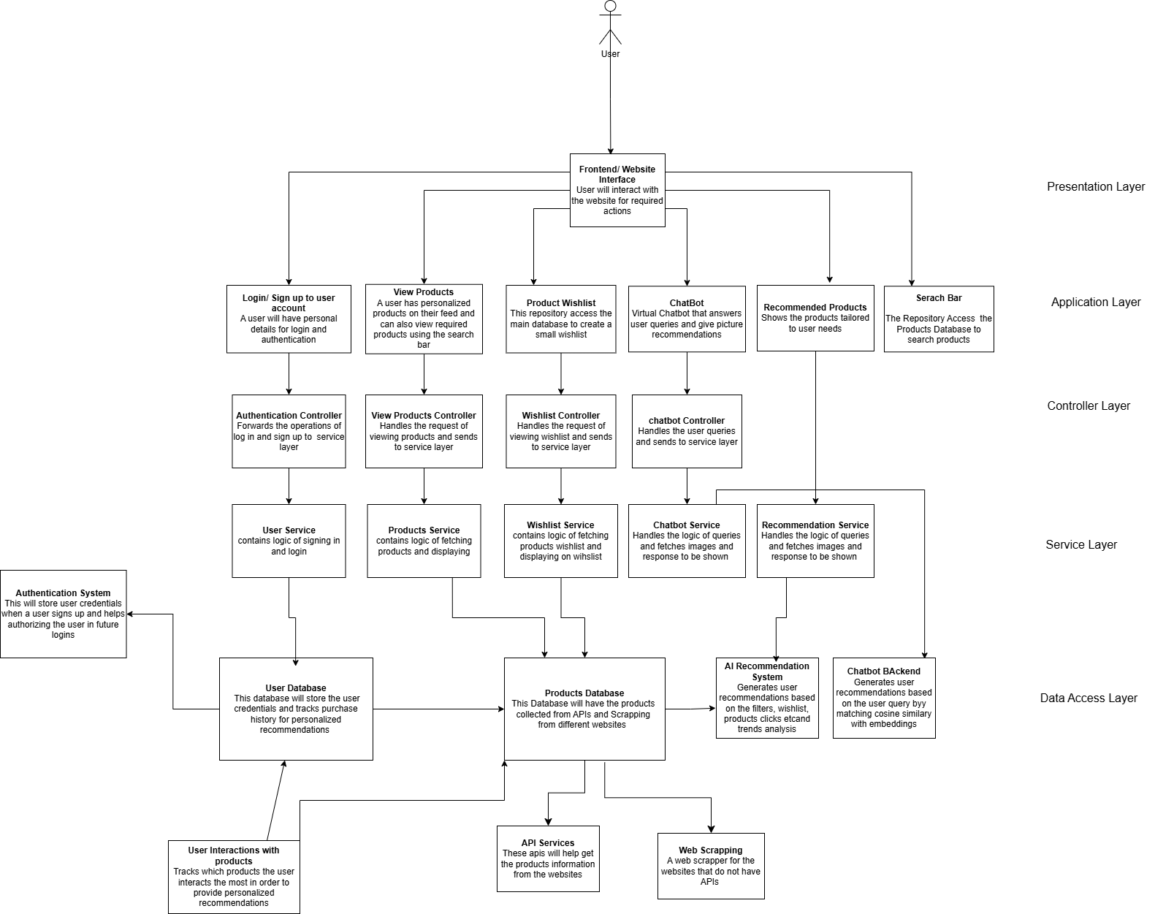

## Architecture Description

This architecture represents a multi-layered web system for a virtual shopping assistant that personalizes fashion product recommendations for users. The system follows a modular, layered architecture comprising five main layers:

**Presentation Layer**

* **Frontend/Website Interface**: This is the entry point where users (shoppers) interact with the system. It provides UI components for logging in, searching, chatting with the assistant, viewing recommendations, and managing wishlists.

**Application Layer**

* **Login/Sign up**: Handles user registration and authentication.
* **View Products**: Displays personalized product feeds and supports keyword-based search.
* **Product Wishlist**: Allows users to save favorite products for later reference.
* **Chatbot**: A virtual assistant that answers user queries and gives suggestions.
* **Recommended Products**: Dynamically displays AI-driven product suggestions.
* **Search Bar**: Connects to the products database to retrieve relevant products.

**Controller Layer**

* **Authentication Controller**: Forwards login/signup requests to the service layer.
* **View Products Controller**: Sends product viewing requests to the service layer.
* **Wishlist Controller**: Manages wishlist operations and communicates with its service.
* **Chatbot Controller**: Handles user chat input and sends it to the service.
* **Recommendation Controller**: Handles user queries for product recommendations

**Service Layer**

* **User Service**: Implements login and registration logic.
* **Products Service**: Fetches and processes product listings.
* **Wishlist Service**: Manages the wishlist by interacting with product data.
* **Chatbot Service**: Processes user queries and generates appropriate chatbot responses.
* **Recommendation Service**: Executes the logic to generate and rank recommendations using the AI module and chatbot backend.

**Data Access Layer**

* **Authentication System**: Verifies user credentials and manages session validation.
* **User Database**: Stores user data and logs interactions to enable personalization.
* **Products Database**: Central product repository, populated via APIs and web scraping.
* **API Services**: Connects with platforms having structured APIs for real-time product data.
* **Web Scraping**: Extracts data from websites that lack APIs.
* **AI Recommendation System**: Uses historical user behavior, embeddings, filters, and trend analysis to return relevant product suggestions.
* **Chatbot Backend**: Uses cosine similarity to map user queries to product embeddings for conversational recommendations.

**Subsystem Interaction**

* When a user visits the interface, they can either sign up, search for products, interact with the chatbot, or view recommendations.
* The **controller layer** acts as an intermediary between UI actions and backend logic.
* Services process the core logic — e.g., **Chatbot Service** generates replies using the **Chatbot Backend**, while **Recommendation Service** calls the **AI Recommendation System**.
* The system fetches product data through **API Services** or **Web Scraping**, which populate the **Products Database**.
* Data from the **User Database** and **User Interactions** supports personalization in the AI modules.
* All components collaborate to ensure a smooth, responsive, and tailored shopping experience.

## Justification of the Architecture

**Pros**

* **Layered Separation of Concerns**: Clear modularity improves maintainability and testing.
* **Scalable**: Each layer can be scaled independently (e.g., caching API responses, load-balancing chatbot backend).
* **Extensible**: New e-commerce platforms can be added by extending API services or web scraping modules.
* **Real-time Personalization**: User data flows directly into AI recommendation pipelines for dynamic suggestions.
* **Decoupled Chatbot Logic**: Chatbot logic is abstracted into its own controller/service/backend, making it easy to replace or upgrade models.

**Cons**

* **Higher Initial Complexity**: Multiple layers and micro-interactions make the system harder to implement at the start.
* **Latency Risk**: Calls between services, databases, and scraping modules could introduce delays if not optimized.
* **Web Scraping Fragility**: Reliance on scraping for non-API platforms can lead to maintenance overhead if site structures change frequently.

**Justification**

This architecture is well-suited for your system because it enables **real-time user interaction**, **modular AI integration**, and **multi-source data aggregation**—all core needs for your personalized shopping assistant. It aligns well with the following non-functional requirements:

* **Performance**: By separating responsibilities and using vector-based matching, the chatbot and recommendation responses can remain fast.
* **Maintainability**: Modular components (e.g., services for wishlist, chatbot) make the system easier to debug, test, and extend.
* **Scalability**: New product categories, recommendation models, or UI features can be added without rewriting core logic.
* **Reliability**: Authentication, logging, and admin controls increase system robustness.
* **Adaptability**: External integrations (e.g., new platforms) can be plugged in via API/Web Scraping without restructuring internal logic.

## Tools and Technologies

**MongoDB (v6.x or later)**

MongoDB will function as the central database for the platform, efficiently managing diverse data types such as user profiles, browsing histories, purchase records, and product catalogs from various local clothing brands. Its document-oriented design offers the flexibility required to handle complex, nested data structures without enforcing rigid schemas, making it ideal for accommodating the dynamic nature of user preferences and product offerings. Additionally, MongoDB's inherent scalability ensures the platform can adeptly handle increasing user traffic and expanding datasets as the business grows.

**Vercel**

Vercel will be utilized to deploy and host the platform's front-end React application. It provides a serverless architecture that delivers fast, secure, and scalable performance, essential for ensuring a seamless user experience. With Vercel's optimized deployment pipeline, the platform can implement continuous integration and delivery, facilitating rapid updates and maintaining high availability for users.

**React (v18.x or later)**

React will serve as the primary framework for constructing the platform's user interface. Its component-based architecture allows for the creation of reusable UI elements, enabling a consistent and responsive design across the platform. React's virtual DOM efficiently updates and renders components, ensuring a smooth and interactive user experience as users navigate through various brands and product listings.

**Node.js (v20.x or later)**

Node.js will power the platform's backend server, handling tasks such as API requests, user authentication, data processing, and integration with the AI-driven recommendation system. Its non-blocking, event-driven architecture is well-suited for managing high-volume, concurrent operations, ensuring the platform remains responsive and efficient even under substantial user load.

**Render (for backend deployment)**

Render will be used to deploy and manage the Node.js backend server. It offers a seamless developer experience with automatic deployment from Git repositories, HTTPS out of the box, and zero-downtime deploys. Render ensures high reliability and scalability for the backend services, including user authentication, recommendation engine interactions, and product data APIs. Its simple configuration and real-time logs aid in faster debugging and easier maintenance of backend services.

**Pinecone (v2.x)**

We plan to use Pinecone (v2.x) as a managed vector database for efficient real-time similarity search and vector storage. It will help us store and query user preference embeddings and clothing feature vectors, critical for generating personalized recommendations. However, we need to further vet Pinecone's integration with our AI recommendation system to ensure it meets the performance and scalability needs of our platform.

**Hugging Face (v4.x)**

We are considering Hugging Face (v4.x) for generating text-based embeddings using pre-trained models like BERT or GPT. These embeddings will enhance our AI system's ability to recommend clothing based on user behavior and inputs. Further analysis is required to finalize the best-suited model for our use case, ensuring the recommendations are accurate and efficient for our platform.

**Amazon S3**

Amazon S3 will serve as the primary storage solution for images associated with each product, reliably handling large volumes of image files with high availability and durability. Each product’s images will be stored in S3 buckets, with unique keys tied to product IDs, enabling straightforward retrieval and efficient organization. This setup allows for flexible scalability, as S3 can easily accommodate an expanding catalog of products and associated images without performance degradation. Additionally, S3's integration with other AWS services enables advanced features like image processing, optimization, and access control, ensuring images are securely managed, optimized for delivery, and quickly accessible for a seamless user experience on the platform.

# 

# Requirements Specifications

Brief introduction of this chapter in a paragraph highlighting the content

## Use Cases

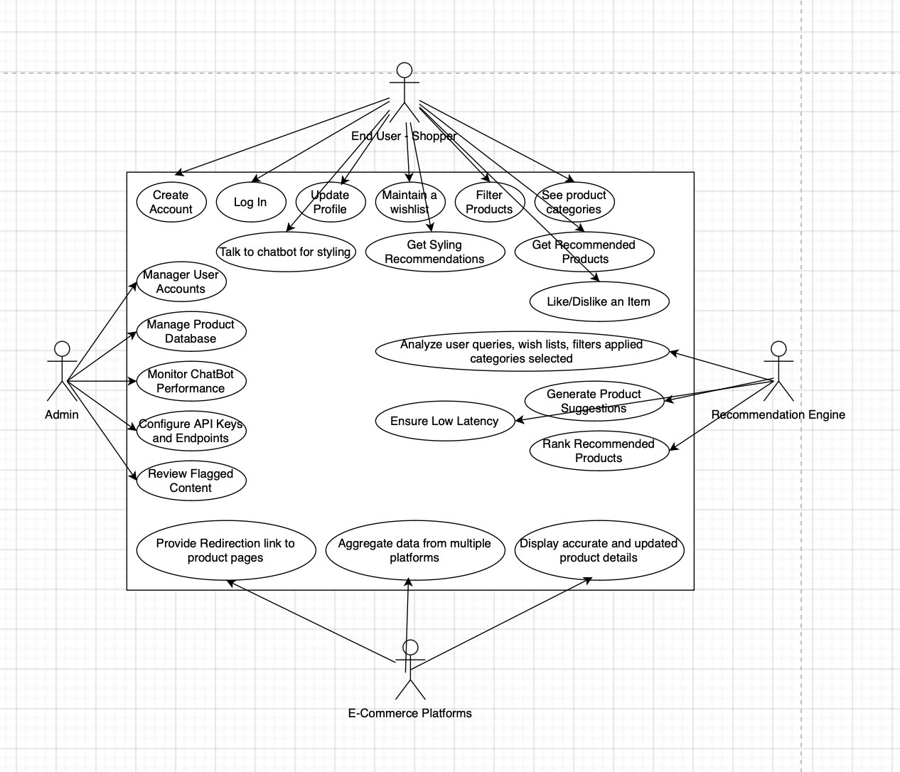

1) Detect seasonal trends

|  |  |  |
| --- | --- | --- |
| **Identifier** | | UC - 001 |
| **Purpose** | | The system detects seasonal clothing trends, such as festive or weather-based preferences. |
| **Pre-conditions** | | Seasonal or festive data is available. |
| **Post-conditions** | | Seasonal trends are identified and suggested to users. |
|  | | |
| **Step #** | **Typical Course of Action** | |
| **1.** | System gathers data on seasonal trends. | |
| **2.** | Season trends are identified | |
| **3.** | System updates recommendations accordingly | |
|  | | |
| **Step #** | **Alternate Courses of Action** | |
| 1. | System can apply last year's seasonal data as a fallback if current data is lacking. | |
| **Step #** | **Exception Paths** | |
| 1. | If no trends are detected, the system flags the issue for admin review and skips seasonal recommendations | |

2) Create Account

|  |  |  |
| --- | --- | --- |
| **Identifier** | | UC-002 |
| **Purpose** | | End user creates an account using email or social media profiles. |
| **Pre-conditions** | | User has email or social media account. |
| **Post-conditions** | | Account is created, user is authenticated. |
|  | | |
| **Step #** | **Typical Course of Action** | |
| **1.** | User signs up. | |
| **2.** | User inputs details | |
| **3.** | System verifies and creates account | |
| **4.** | User is authenticated | |
|  |  | |
|  | | |
| **Step #** | **Alternate Courses of Action** | |
| 1. | User can skip email verification and use social media login for quicker sign-up. | |
| **Step #** | **Exception Paths** | |
| 1. | If email/social media validation fails, the user is prompted to retry or choose another method. | |

3) Receive personalized product recommendations

|  |  |  |
| --- | --- | --- |
| **Identifier** | | UC - 003 |
| **Purpose** | | End user receives personalized recommendations based on preferences and past purchases. |
| **Pre-conditions** | | User profile and purchase history are available. |
| **Post-conditions** | | Tailored product recommendations are shown to the user. |
|  | | |
| **Step #** | **Typical Course of Action** | |
| **1.** | User logs in | |
| **2.** | System analyzes preferences and past purchases. | |
| **3.** | Recommendations are displayed | |
|  | | |
| **Step #** | **Alternate Courses of Action** | |
| 1. | System can prioritize current trends over past purchases for recommendations. | |
| **Step #** | **Exception Paths** | |
| 1. | If recommendations cannot be generated, the system defaults to general popular products. | |

4) Save products to a wishlist

|  |  |  |
| --- | --- | --- |
| **Identifier** | | UC - 004 |
| **Purpose** | | End user saves products to a wishlist for future reference. |
| **Pre-conditions** | | User is logged in. |
| **Post-conditions** | | Products are added to user’s wishlist |
|  | | |
| **Step #** | **Typical Course of Action** | |
| 1. **1.** | User selects a product. | |
| 1. **2.** | User saves the product to wishlist. | |
| 1. **3.** | System updates user’s wishlist. | |
|  | | |
| **Step #** | **Alternate Courses of Action** | |
| 1. | User can remove an item from the wishlist at any time | |
| **Step #** | **Exception Paths** | |
| 1. | If the product cannot be saved, an error is displayed, and the user is prompted to retry. | |

5) Filter products based on price, brand, and category

|  |  |  |
| --- | --- | --- |
| **Identifier** | | UC-005 |
| **Purpose** | | End user filters products based on specific criteria (e.g., price, brand, or category). |
| **Pre-conditions** | | User has performed a search or is browsing |
| **Post-conditions** | | Filtered product results are displayed. |
|  | | |
| **Step #** | **Typical Course of Action** | |
| **1.** | User inputs filter criteria. | |
| **2.** | System applies filters | |
| **3.** | Filtered results are displayed to user | |
|  | | |
| **Step #** | **Alternate Courses of Action** | |
| 1. | User can change filter criteria at any time for a different view. | |
| **Step #** | **Exception Paths** | |
| 1. | If filtering fails, all products are displayed by default. | |

6) Like or dislike products

|  |  |  |
| --- | --- | --- |
| **Identifier** | | UC-006 |
| **Purpose** | | End user likes or dislikes products, refining future recommendations |
| **Pre-conditions** | | User is logged in and has viewed products. |
| **Post-conditions** | | Future product recommendations are refined based on user feedback. |
|  | | |
| **Step #** | **Typical Course of Action** | |
|  | User views products. | |
|  | User likes/dislikes a product. | |
|  | System records user feedback | |
| **8.** | Recommendations improve based on input | |
|  | | |
| **Step #** | **Alternate Courses of Action** | |
| 1. | User can undo a like/dislike action if done accidentally | |
| **Step #** | **Exception Paths** | |
| 1. | If feedback is not recorded, the user is notified, and the action is retried. | |

7) Retrieve product data

|  |  |  |
| --- | --- | --- |
| **Identifier** | | UC-007 |
| **Purpose** | | The system retrieves product data like descriptions, reviews, prices, and availability from e-commerce APIs or web scraping. |
| **Pre-conditions** | | APIs or scraping tools are available and functioning |
| **Post-conditions** | | Product data is retrieved and displayed to users. |
|  | | |
| **Step #** | **Typical Course of Action** | |
| **1.** | System sends request to e-commerce API or scrapes website. | |
| **2.** | Product data is fetched. | |
| **3.** | System displays data to users | |
|  | | |
| **Step #** | **Alternate Courses of Action** | |
| 1. | System can fallback to previously cached data if API or scraping fails. | |
| **Step #** | **Exception Paths** | |
| 2. | If the product data cannot be fetched, a message informs the user and no data is displayed. | |

8) Display real-time product details

|  |  |  |
| --- | --- | --- |
| **Identifier** | | UC-008 |
| **Purpose** | | The system displays accurate and up-to-date product details to users in real-time. |
| **Pre-conditions** | | APIs or scraping tools are available and functioning. |
| **Post-conditions** | | Real-time product details are visible to users. |
|  | | |
| **Step #** | **Typical Course of Action** | |
| **1.** | System sends request for product details | |
| **2.** | Product details are displayed in real-time. | |
|  | | |
| **Step #** | **Alternate Courses of Action** | |
| 1. | If the system detects outdated data, it can request an update. | |
| **Step #** | **Exception Paths** | |
| 2. | If real-time details are unavailable, a message informs users of the issue. | |

9) Provide redirection links

|  |  |  |
| --- | --- | --- |
| **Identifier** | | UC-009 |
| **Purpose** | | The system provides redirection links to product pages where users can complete purchases |
| **Pre-conditions** | | Products have valid e-commerce links. |
| **Post-conditions** | | Users are redirected to external platforms to complete their purchases. |
|  | | |
| **Step #** | **Typical Course of Action** | |
| **1.** | User clicks on a product link. | |
| **2.** | System generates and displays a redirection link. | |
| **3.** | User is redirected to the external platform | |
|  | | |
| **Step #** | **Alternate Courses of Action** | |
| 1. | System can offer users a "confirm" option before redirection occurs. | |
| **Step #** | **Exception Paths** | |
| 2. | If redirection fails, users are shown a message and remain on the platform. | |

10) 1.1.1 Monitor system performance

|  |  |  |
| --- | --- | --- |
| **Identifier** | | UC-010 |
| **Purpose** | | Admin monitors system performance and integrations with e-commerce platforms. |
| **Pre-conditions** | | System is running and admin has access |
| **Post-conditions** | | Admin views the status of system performance and integrations. |
|  | | |
| **Step #** | **Typical Course of Action** | |
| **1.** | Admin logs in | |
| **2.** | Admin checks performance metrics | |
| **3/** | Asmin identifies performance issues | |
| **4.** | Admin takes actions as necessary | |
|  | | |
| **Step #** | **Alternate Courses of Action** | |
| 1 | Admin can skip detailed checks and directly apply general fixes. | |
| **Step #** | **Exception Paths** | |
| 2. | If system integration is broken, an alert is generated, and further diagnostic steps are required. | |

## Class Diagram

Use standard UML notation to draw the class diagram. Give brief description/purpose of each class in the class diagram. Give readable names to classes, attributes and operations.

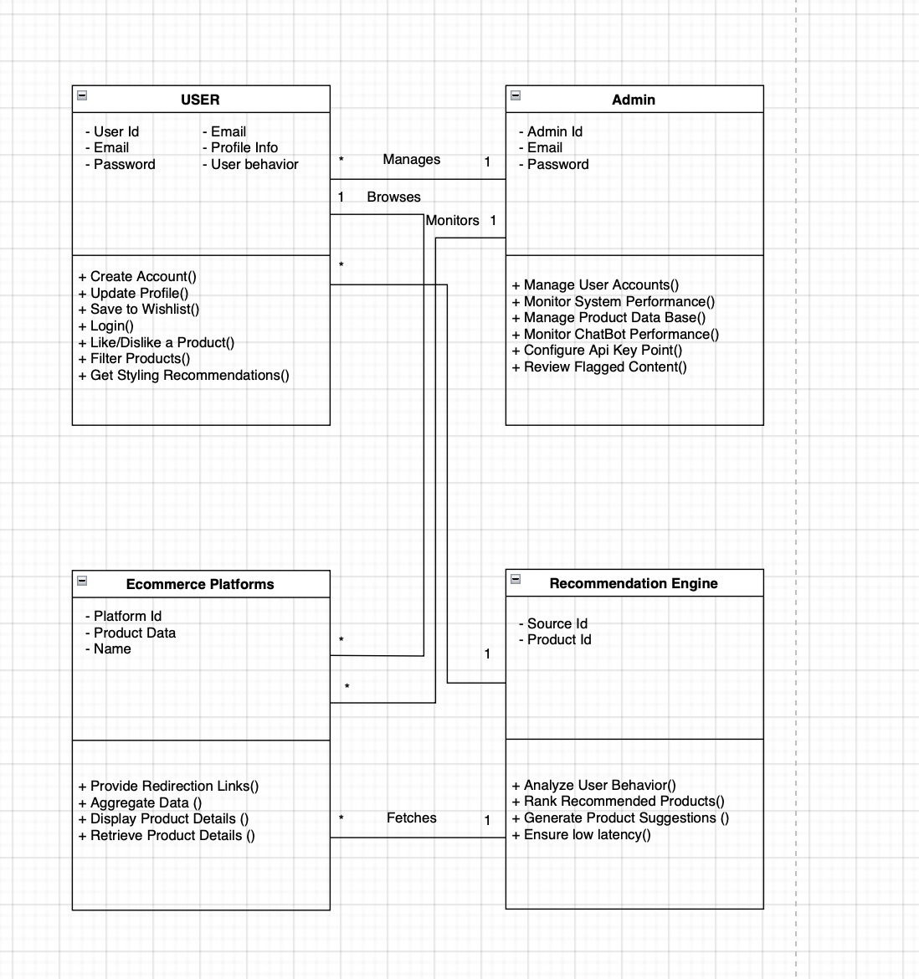

### **1. User**

**Purpose:**  
Represents the end-user of the system who interacts with the platform to browse, filter, and receive personalized product recommendations.

**Key Features:**

* Can create and manage their account.
* Interacts with products (like/dislike, save to wishlist).
* Receives styling recommendations based on behavior.

### **2. Admin**

**Purpose:**  
Responsible for managing and maintaining the overall system, including user accounts, data sources, and chatbot/API configurations.

**Key Features:**

* Manages user accounts and product database.
* Monitors system and chatbot performance.
* Reviews flagged content and configures API endpoints.

### **3. Ecommerce Platforms**

**Purpose:**  
Represents the external platforms (e.g., Khaadi, Sapphire) from which product data is scraped or aggregated.

**Key Features:**

* Provides redirection links to actual product pages.
* Supplies product data for aggregation.
* Supports product display and detail retrieval functions.

### **4. Recommendation Engine**

**Purpose:**  
Analyzes user behavior and provides personalized product recommendations based on various factors like preferences, likes/dislikes, and browsing patterns.

**Key Features:**

* Analyzes behavioral data.
* Ranks and generates product suggestions.
* Optimizes performance for low latency in recommendations.

## Sequence Diagrams

1) Browse Products on Feed

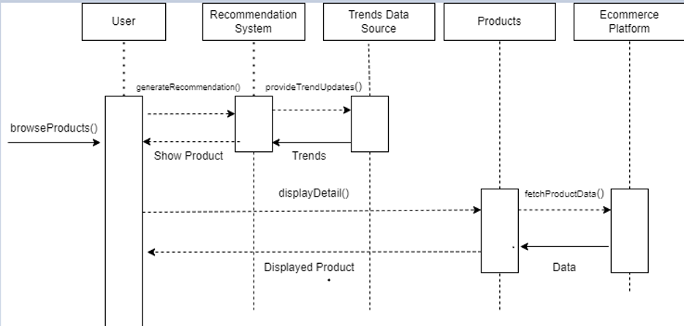

# 2) Search For Products

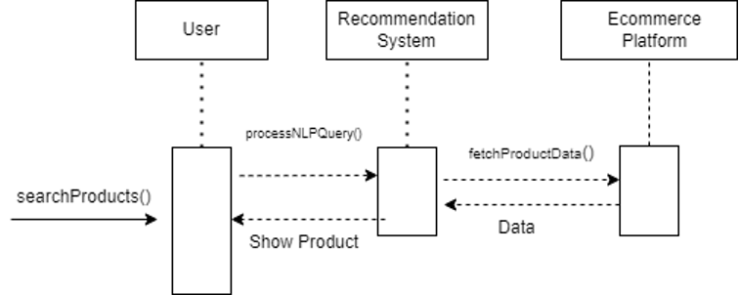

3) Like a product

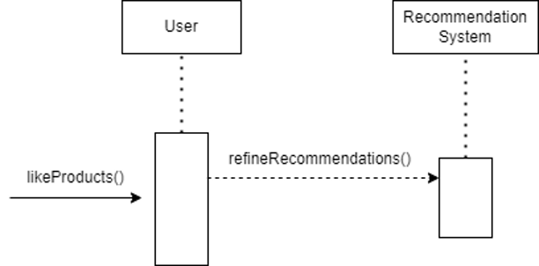

4) CheckOut Products / Redirecting to E commerce Website

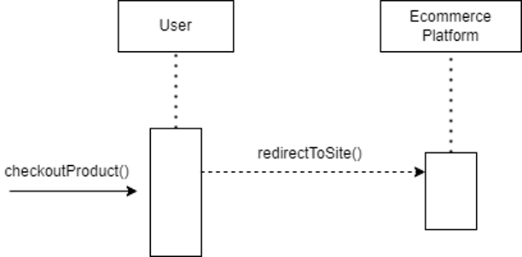

5) Update Personal Information

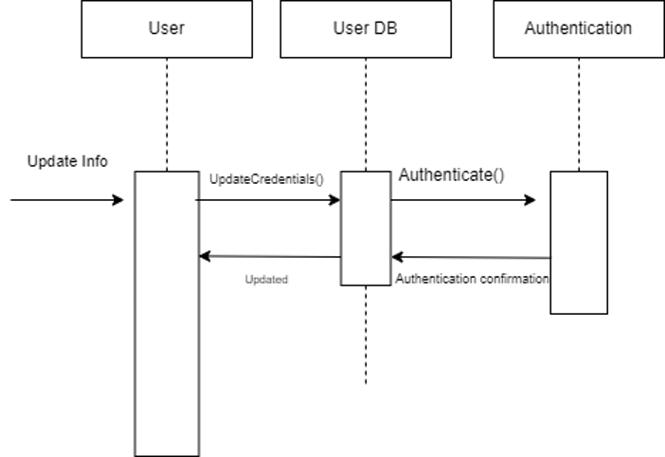

6) Update User WishList

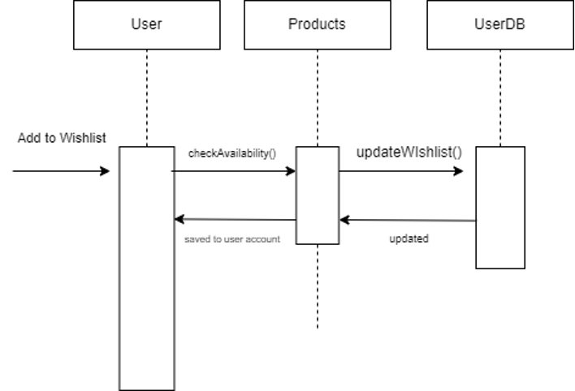

7) Filter Search Products

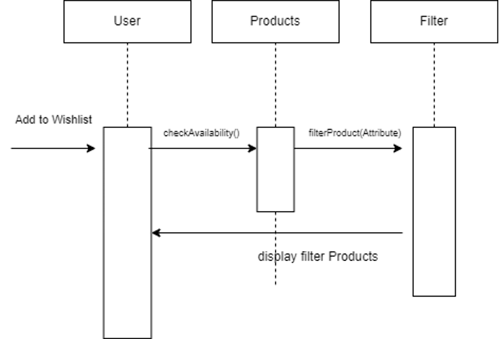

8) **Gather real time data form e commerce website for updated recommendations**

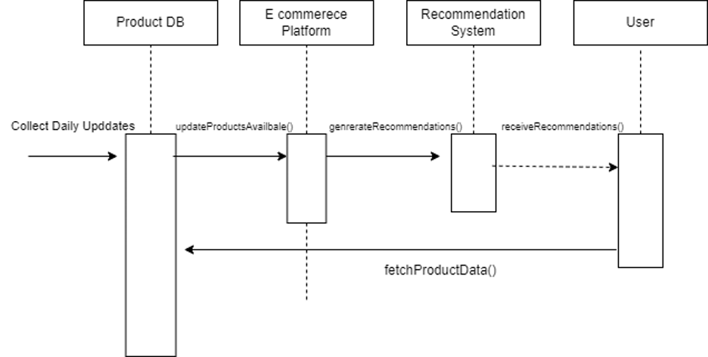

9) Learning User Behaviors and Refining Recommendations

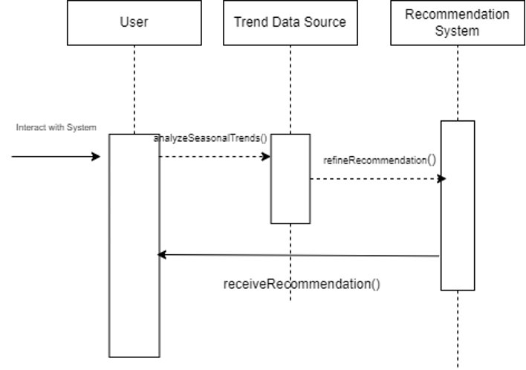

10) Scrapping Fashion data from E commerce Websites

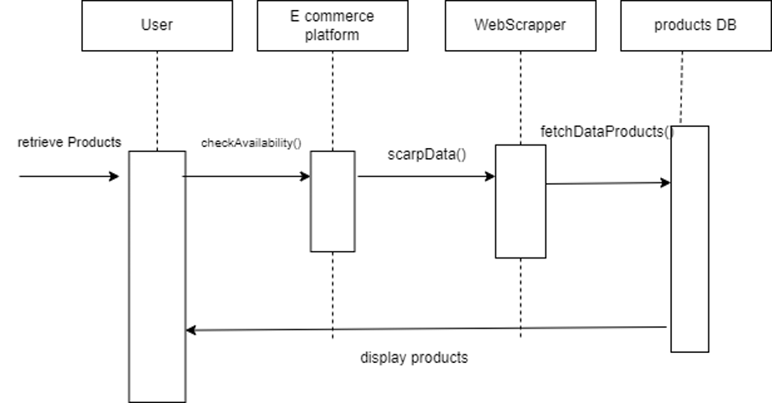

# Software Development Methodology and Plan

This chapter outlines the approach we used to manage and execute the development of *Shop Savvy*. It begins by evaluating different software process models—namely, Waterfall and Agile (Scrum)—highlighting their advantages and disadvantages. We then justify our selected methodology based on the specific needs of our project. Additionally, we provide a contextual analysis of our project's nature, structure, and requirements, which influenced our decision to adopt a flexible, feedback-oriented process. The chosen methodology shaped our development roadmap, team roles, sprint cycles, and feature delivery strategy.

## Software Process Selection

#### **Pros and Cons of Waterfall and Agile (Scrum)**

**Waterfall:**  
Waterfall is a linear, step-by-step approach where each phase of development is completed before moving on to the next.

* **Pros:**
  + **Clear structure:** Waterfall follows a straightforward process, making it easier to manage and plan.
  + **Well-documented:** Every stage is documented, which helps track progress and make onboarding smoother.
  + **Predictable outcomes:** Once the requirements are set, the final product typically aligns with the initial scope.
* **Cons:**
  + **Inflexible:** Difficult to adapt to new changes once a phase is completed.
  + **Limited adaptability:** Poor fit for projects where requirements evolve over time.
  + **Not ideal for evolving projects:** Complex projects with changing dynamics, like AI or API integrations, struggle under Waterfall’s rigid structure.

**Agile (Scrum):**  
Agile breaks the project into smaller, iterative cycles (sprints), allowing for more flexibility and faster feedback.

* **Pros:**
  + **Adaptable:** Agile allows for adjustments based on feedback or changes in requirements.
  + **Encourages collaboration:** Teams work closely with frequent check-ins, leading to quicker problem-solving.
  + **Incremental results:** Delivers working product versions at the end of each sprint, helping detect and fix issues early.
* **Cons:**
  + **Requires experienced teams:** Agile depends on team autonomy, which can be hard for inexperienced teams.
  + **Less predictability:** Project timelines and final scope are more flexible, making it harder to predict.
  + **Scope creep:** Continuous changes can lead to adding more features than originally planned, risking delays.

### **Project Context Analysis**

*Shop Savvy* is a virtual AI-based fashion shopping assistant aimed at delivering a personalized and trend-aware shopping experience for users. The project operates in a dynamic and user-driven domain, where both technical complexity and changing customer expectations must be addressed.

Key characteristics of the project include:

* **Evolving Requirements:**  
  Our platform interfaces with multiple third-party APIs, scrapes dynamic fashion data, and integrates an AI recommendation engine. These features require the system to adapt rapidly to API structure changes, product availability, and seasonal fashion trends.
* **Modular Architecture:**  
  The application consists of distinct but interconnected modules: a React frontend, an Express backend, a MongoDB database, and a real-time AI recommender system deployed on Render. Each module must be developed, tested, and integrated iteratively, supporting continuous improvement.
* **User-Centric Design:**  
  The success of *Shop Savvy* depends heavily on end-user satisfaction. Continuous feedback from testing users is essential to refine recommendation accuracy, user interface design, and interactive features like wishlists and filters.
* **Data-Driven Personalization:**  
  The recommendation engine leverages user behavior data in real-time, requiring frequent iteration to improve vector modeling, weight assignments, and recommendation logic based on evolving usage patterns.
* **Collaborative Development:**  
  The team followed a collaborative, sprint-based structure, distributing tasks such as UI/UX design, API integration, data preprocessing, backend routing, and deployment. Frequent meetings were essential to address blockers, review progress, and reprioritize features.

Given these considerations, a rigid and linear process like Waterfall would have severely limited our ability to adapt. Instead, a flexible, feedback-oriented model was necessary to handle change, uncertainty, and modular iteration.

### **Selected Process: Agile (Scrum)**

**Justification:**

Agile Scrum was chosen for *Shop Savvy* because the project involves dynamic elements such as evolving API integrations with fashion platforms and real-time trend analysis using AI. These aspects require a flexible and adaptive approach that can accommodate frequent changes and new information.

1. **Real-time adaptability:**  
   In *Shop Savvy*, the AI recommendation system relies on trends that change frequently, and the platform integrates with various APIs. Agile allows the team to adapt and make quick adjustments during sprints without the rigid structure of Waterfall. This is crucial for maintaining up-to-date, relevant recommendations for users.
2. **Incremental feature development:**  
   Since *Shop Savvy* consists of multiple components—backend integration, AI models, frontend interfaces—it benefits from Agile’s incremental approach. The team can develop core features (like personalized recommendations) first, gather feedback, and continuously improve them in future sprints. This minimizes risks by delivering working components early and refining them based on real-world usage.
3. **Frequent feedback and user involvement:**  
   The Agile process allows for regular feedback from potential users and stakeholders, helping the team shape the platform based on real user needs. For a consumer-facing platform like *Shop Savvy*, gathering insights about user preferences during the development cycle ensures the final product is aligned with the market.
4. **Handling evolving requirements:**  
   As *Shop Savvy* interacts with multiple external platforms and involves AI-driven recommendations, new requirements or changes in APIs might arise frequently. Agile’s iterative process helps in incorporating these changes seamlessly, ensuring that the system remains current and functional.

**Conclusion:**  
Agile Scrum’s adaptability and focus on continuous feedback make it the best fit for *Shop Savvy*, allowing the team to navigate the complexities of API integration, real-time data processing, and the evolving nature of user preferences efficiently.

## Gantt Chart

The Gantt chart illustrates our project’s schedule. The Gantt chart shows the following:

* Tasks
* Duration (in weeks)
* Milestones
* Team member names who have worked on each task (denoted by a colored DOT)

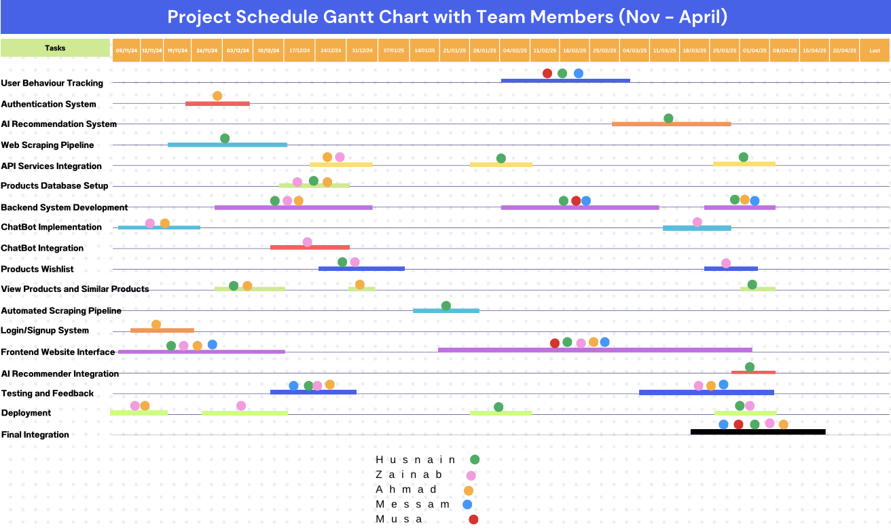

# Database Design and Web Services

The chapter contains our Database design, how all entities are connected together and covers all the schemas.

## Database Design

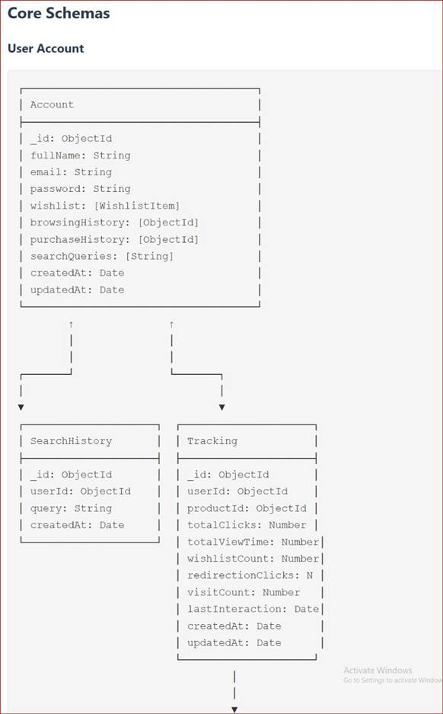

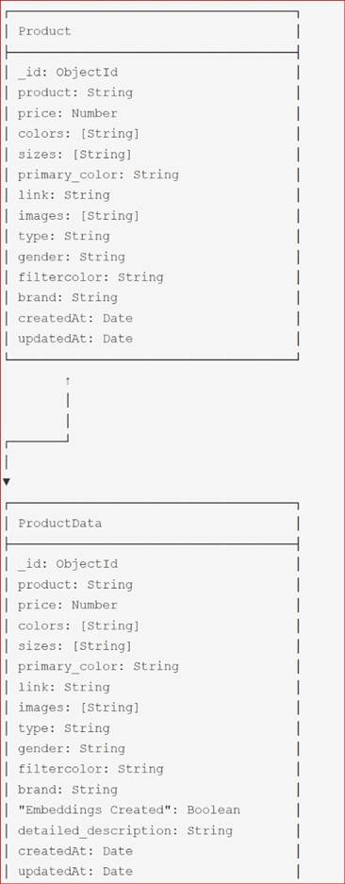

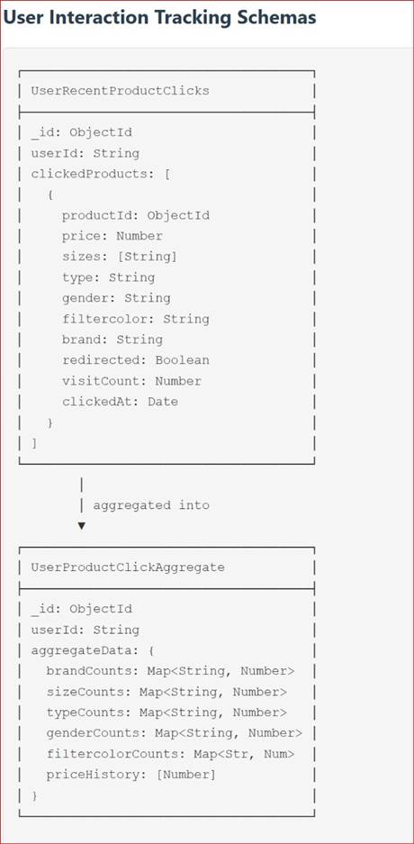

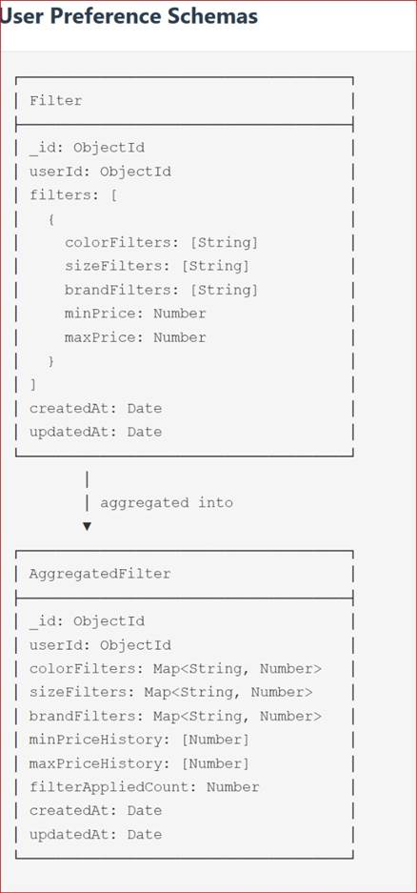

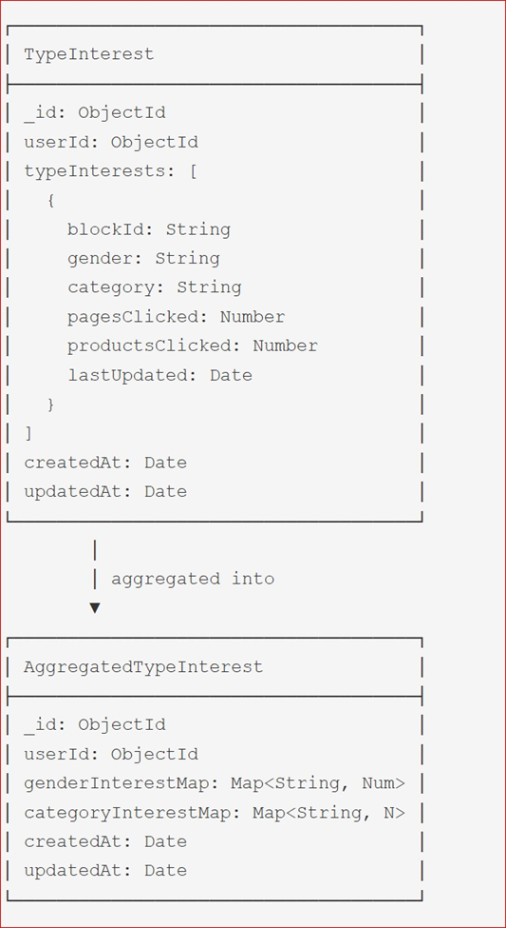

## API Specification

**1. OpenAI GPT-4.0 Mini API**

* **Purpose:** Used to generate rich, detailed product descriptions based on structured product attributes such as color, size, fabric, and style.
* **Functionality:** Converts attribute-level data into engaging and natural-sounding descriptions that enhance product listings.
* **Use Case:** Automatically generates product descriptions during the ingestion phase and stores them in the Products Database for improved user experience and recommendation quality.

**2. Hugging Face Inference API**

* **Model Used:** Sentence Transformers (e.g., all-MiniLM-L6-v2)
* **Purpose:** Converts product descriptions and user input into high-dimensional vector embeddings.
* **Functionality:** Enables semantic understanding of text for the recommendation engine by generating vector representations.
* **Use Case:** Used to embed both user queries and product descriptions for similarity comparison in Pinecone.

**3. Pinecone API**

* **Purpose:** Serves as a vector database to store and query embeddings for real-time similarity search.
* **Functionality:** Allows fast and scalable nearest neighbor search based on cosine similarity.
* **Use Case:** Matches user query embeddings with product embeddings to fetch the most relevant clothing recommendations across platforms.

**4. LLaMA 8B via Hugging Face Endpoint**

* **Purpose:** Powers the virtual chatbot assistant that interacts with users in natural language.
* **Functionality:** Understands user queries, extracts preferences, and generates conversational responses based on matched products.
* **Use Case:** Helps users explore fashion options and ask questions, while enabling the assistant to generate human-like responses using contextual embeddings and product data.

# System User Interface

This chapter provides a comprehensive overview of the graphical user interface (GUI) of our application, “Shop Savvy,” from the perspective of an end user. The interface has been designed with usability, clarity, and responsiveness in mind to offer a seamless shopping experience. The features allow users to browse a large variety of products, apply filters, view recommendations, manage their wishlist, and access personal profiles. Below are the major components of the interface along with brief descriptions and corresponding screenshots.

### **1. Login Page**

The login page allows existing users to securely access their accounts using their email and password credentials.

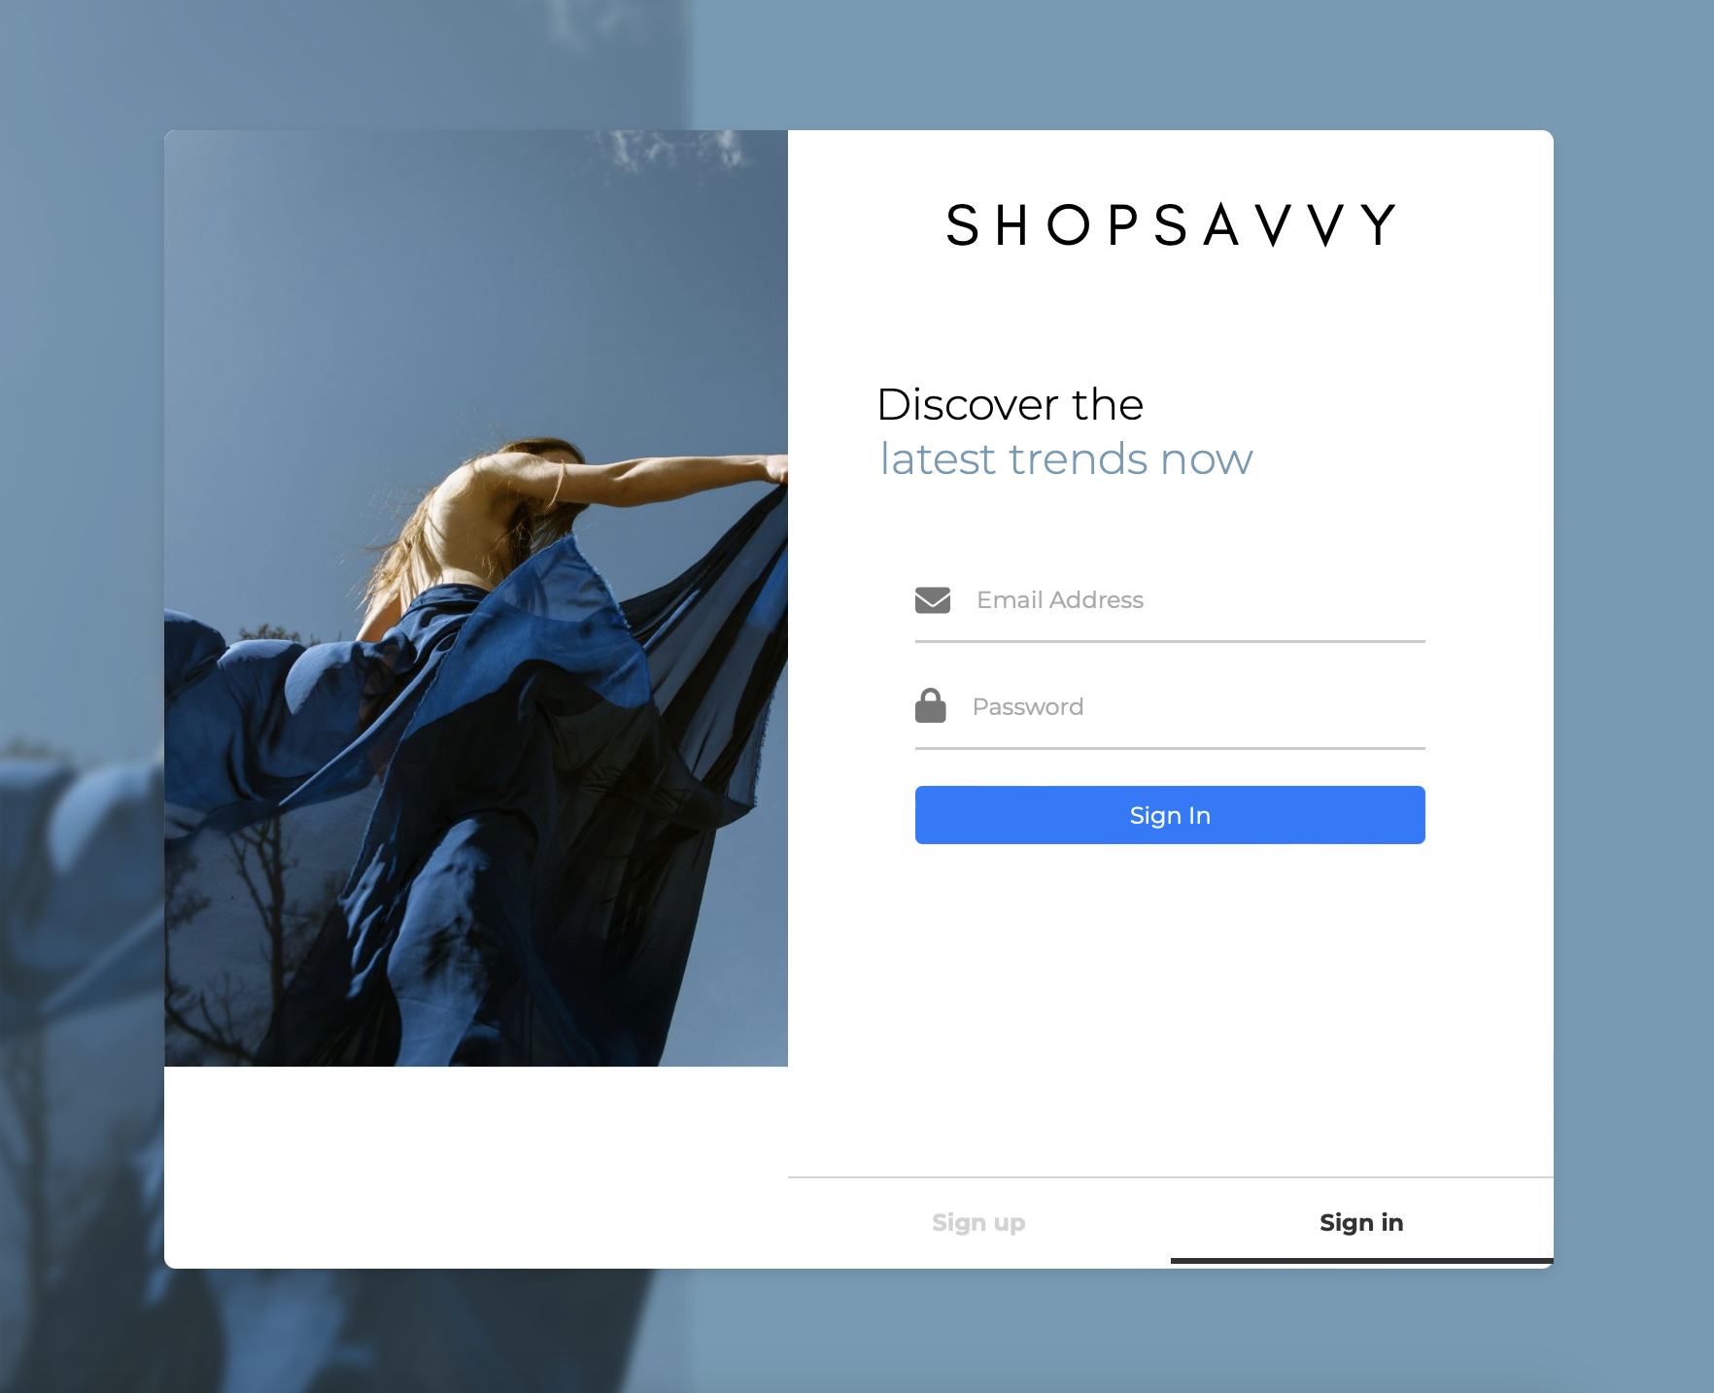

### **2. Signup Page**

New users can register by providing their name, email, and password. Form validation is included to ensure secure and complete entries.

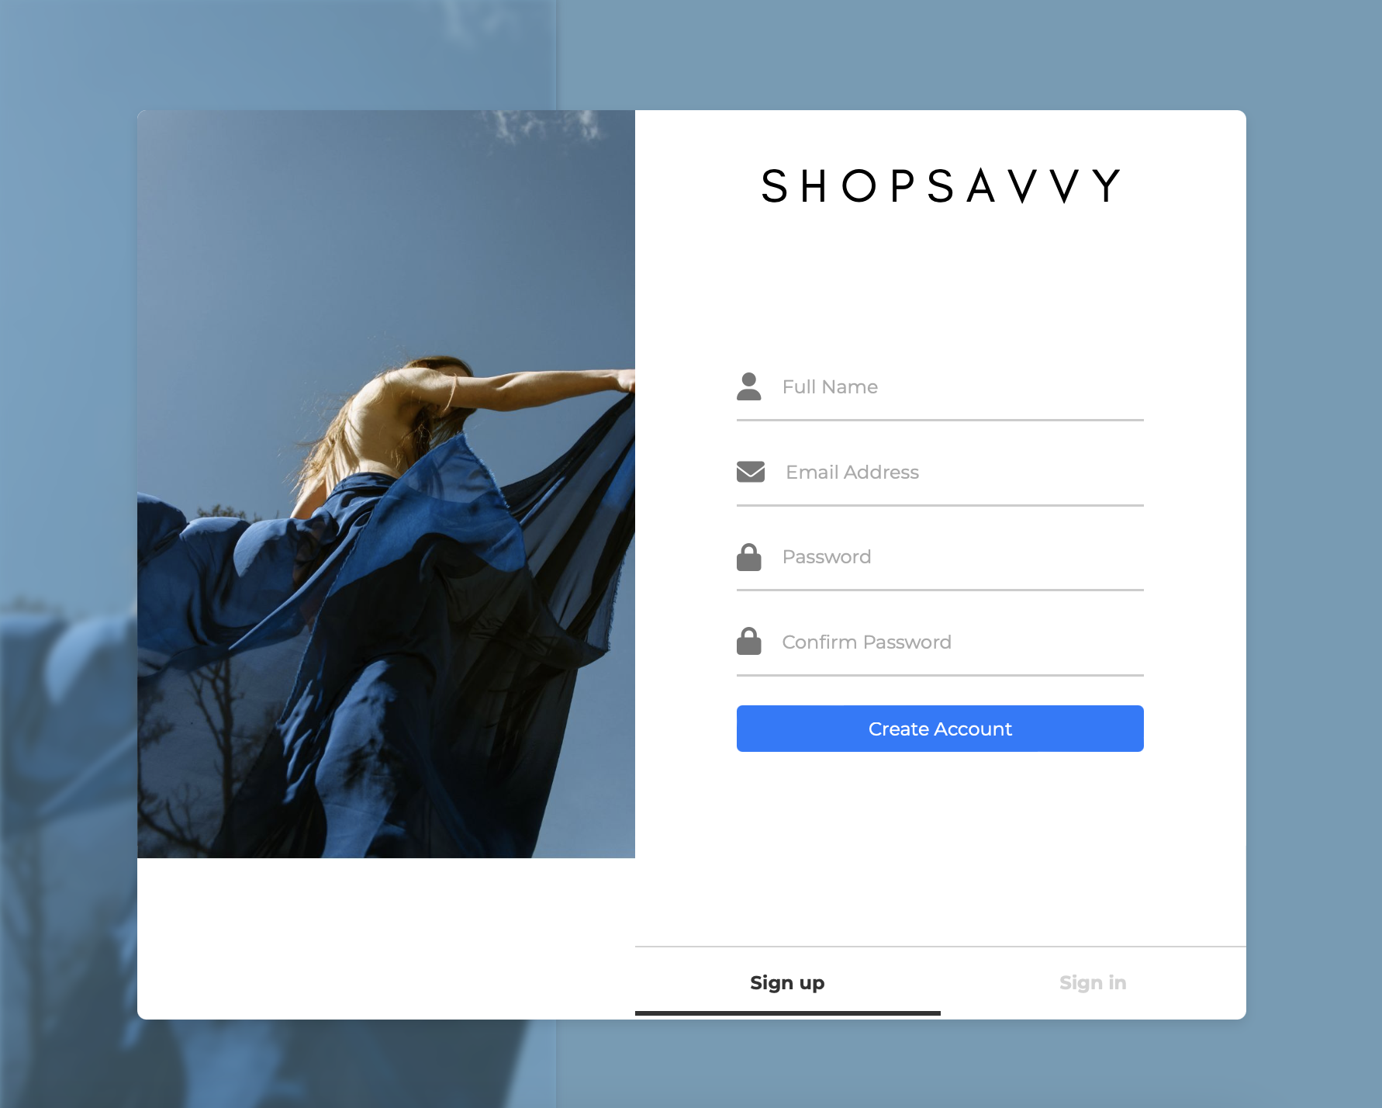

### **3. Homepage**

The homepage acts as the central dashboard, showcasing:

* **Recommended Products**
* **Previously Viewed Products**
* **All Products**
* A link to view the recommended products or the entire product catalog.

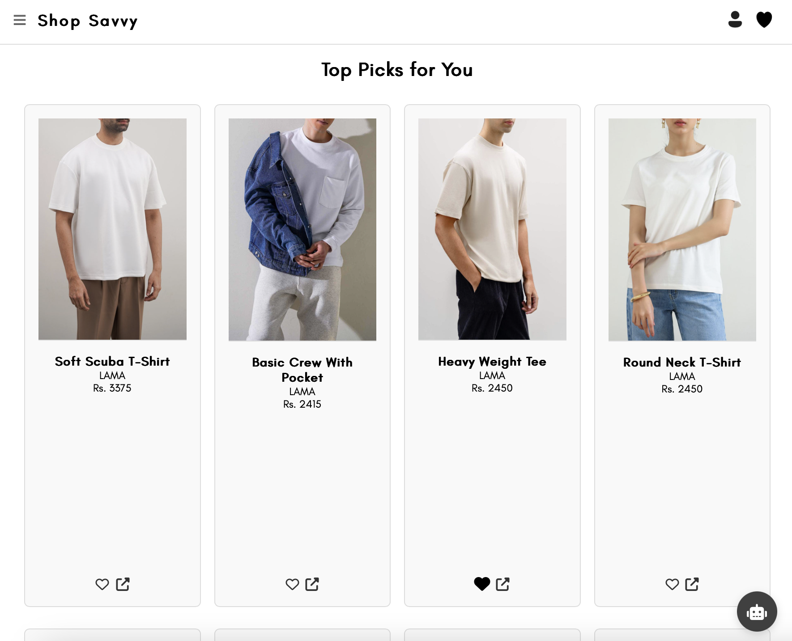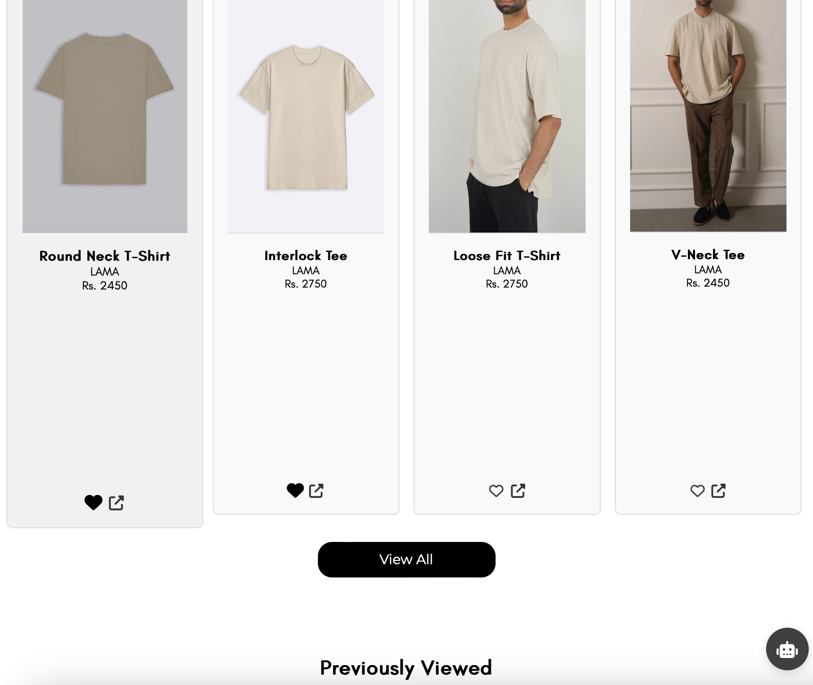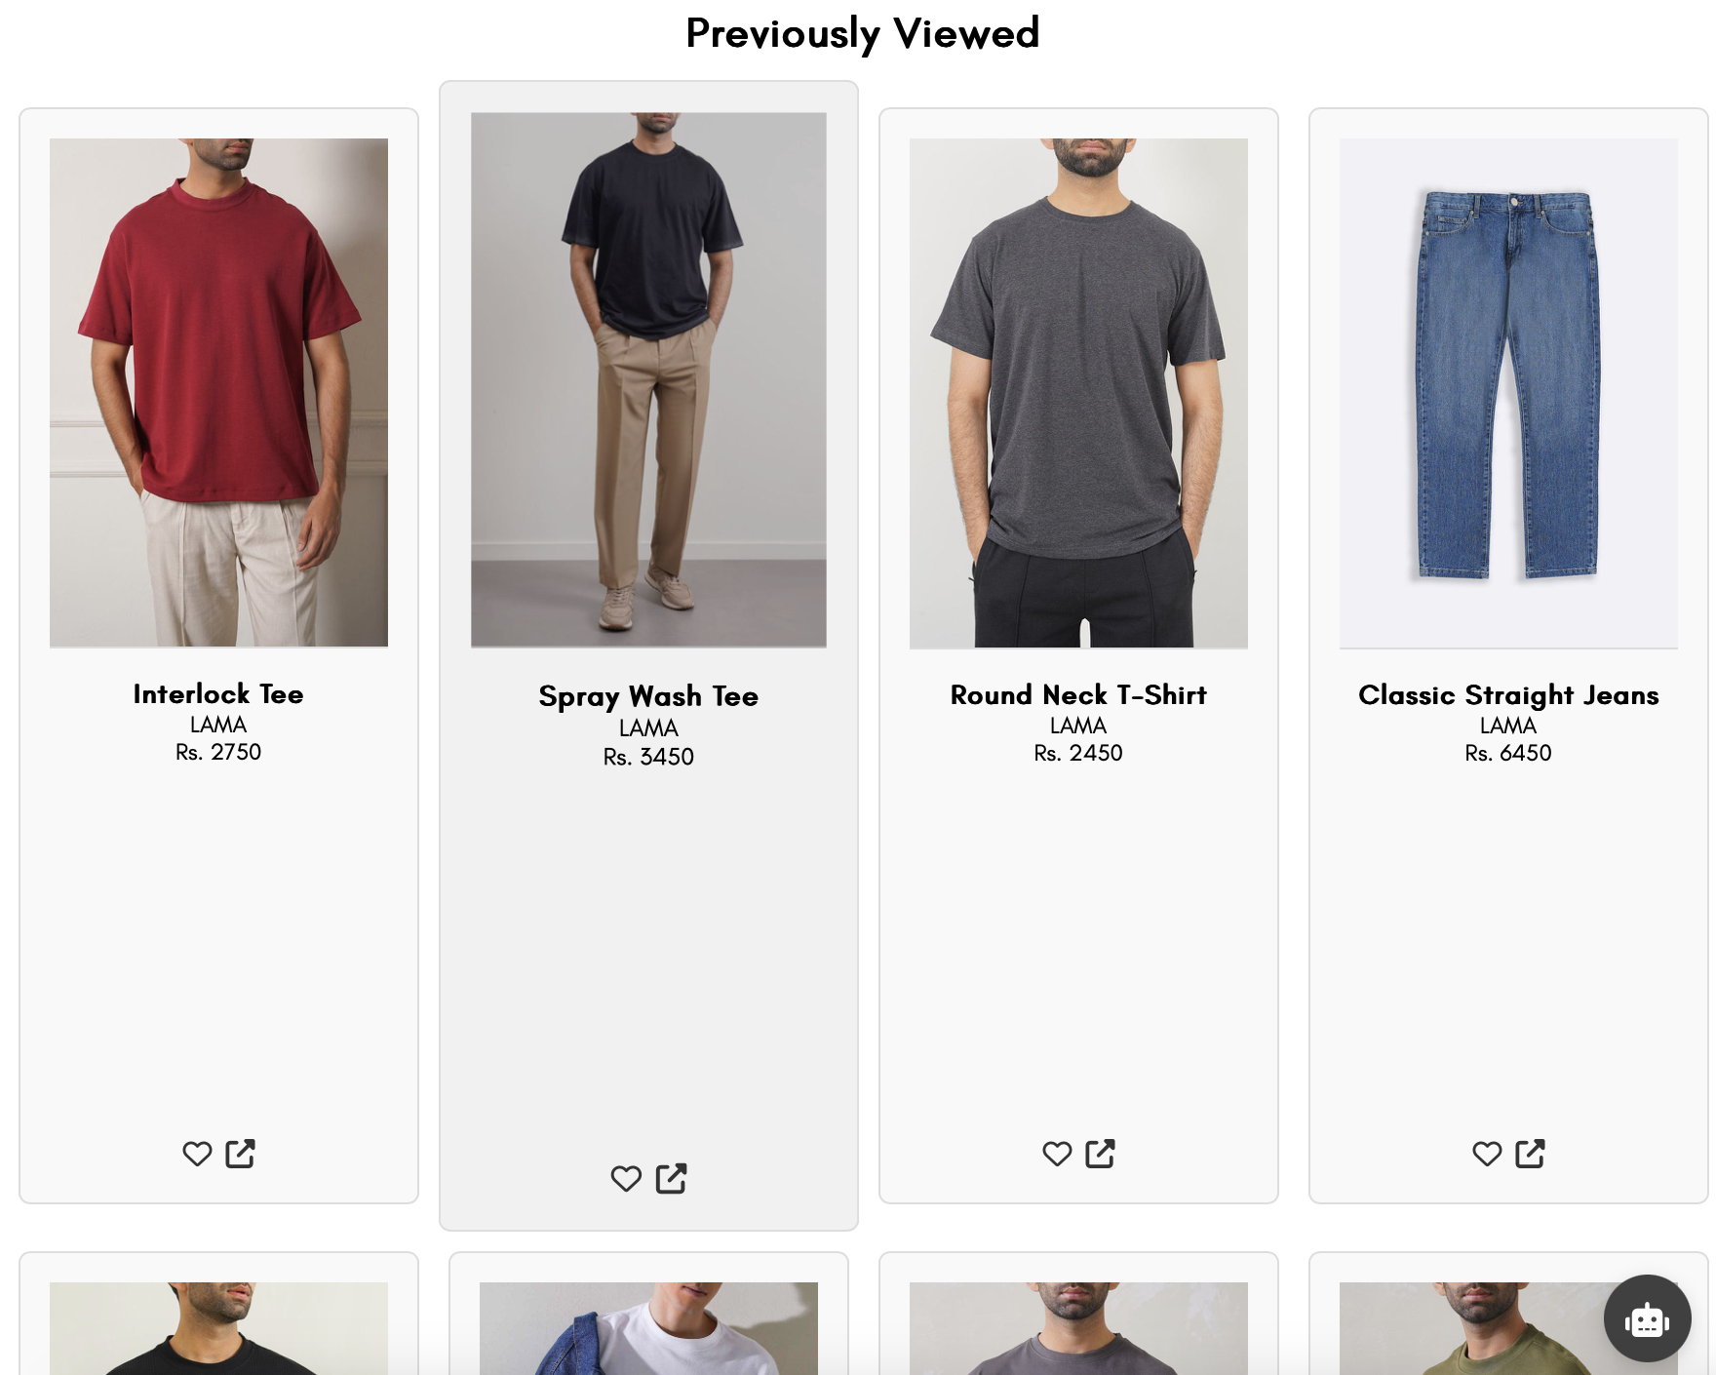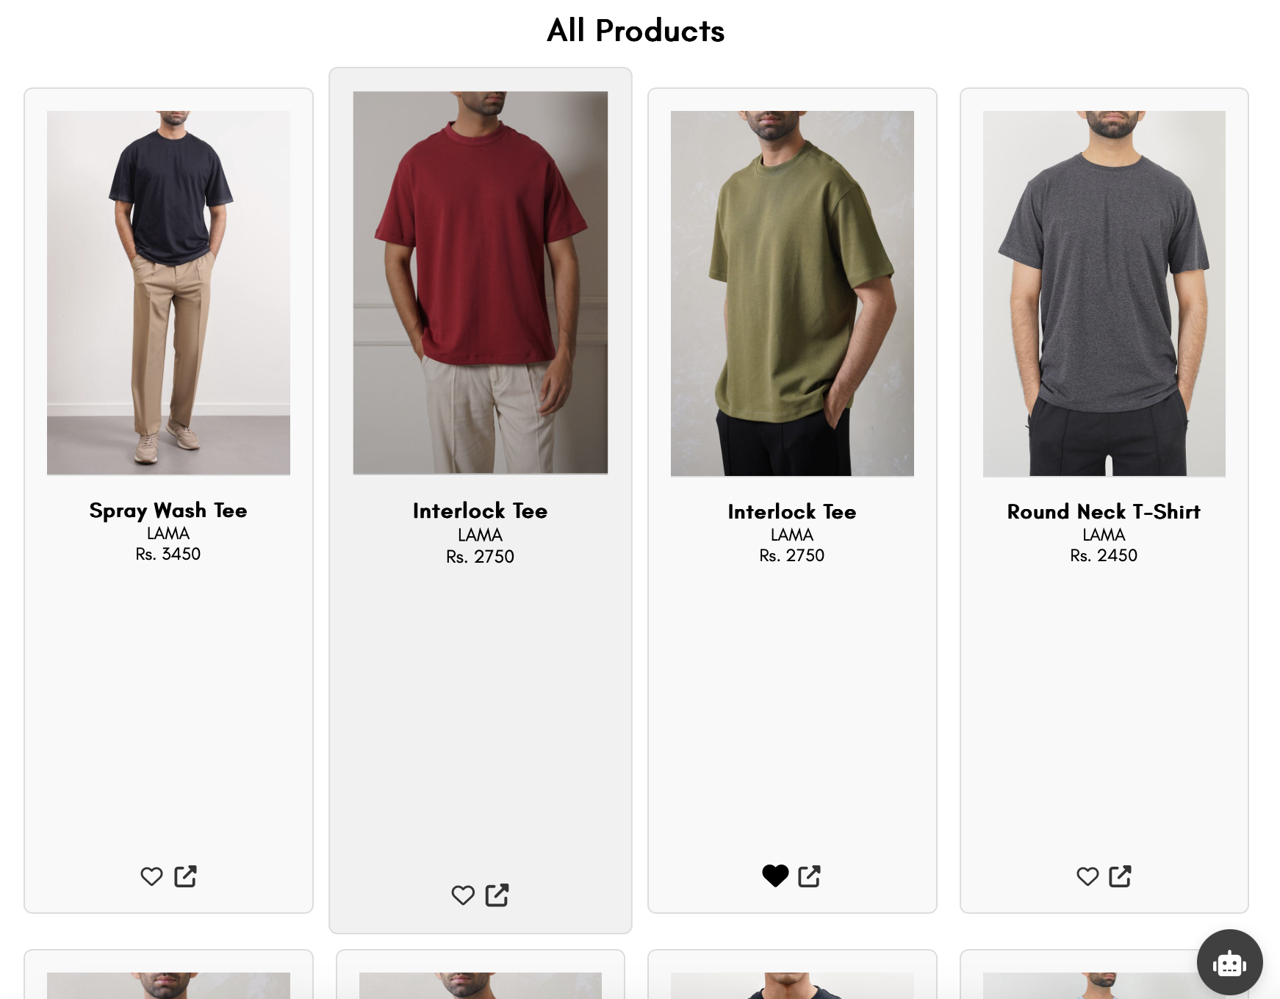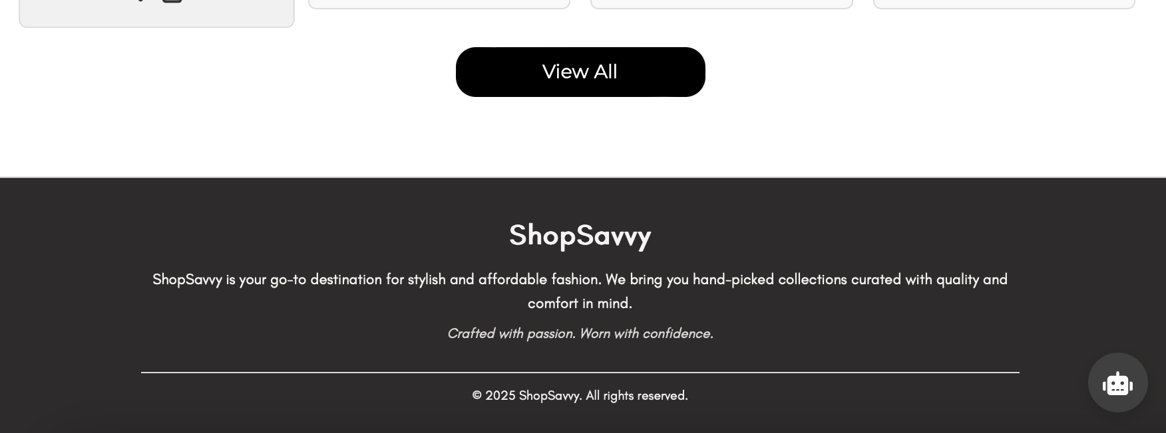

### **4. Recommended Products Section**

This section highlights the top 100 AI-curated product recommendations based on the user’s preferences and interaction history.

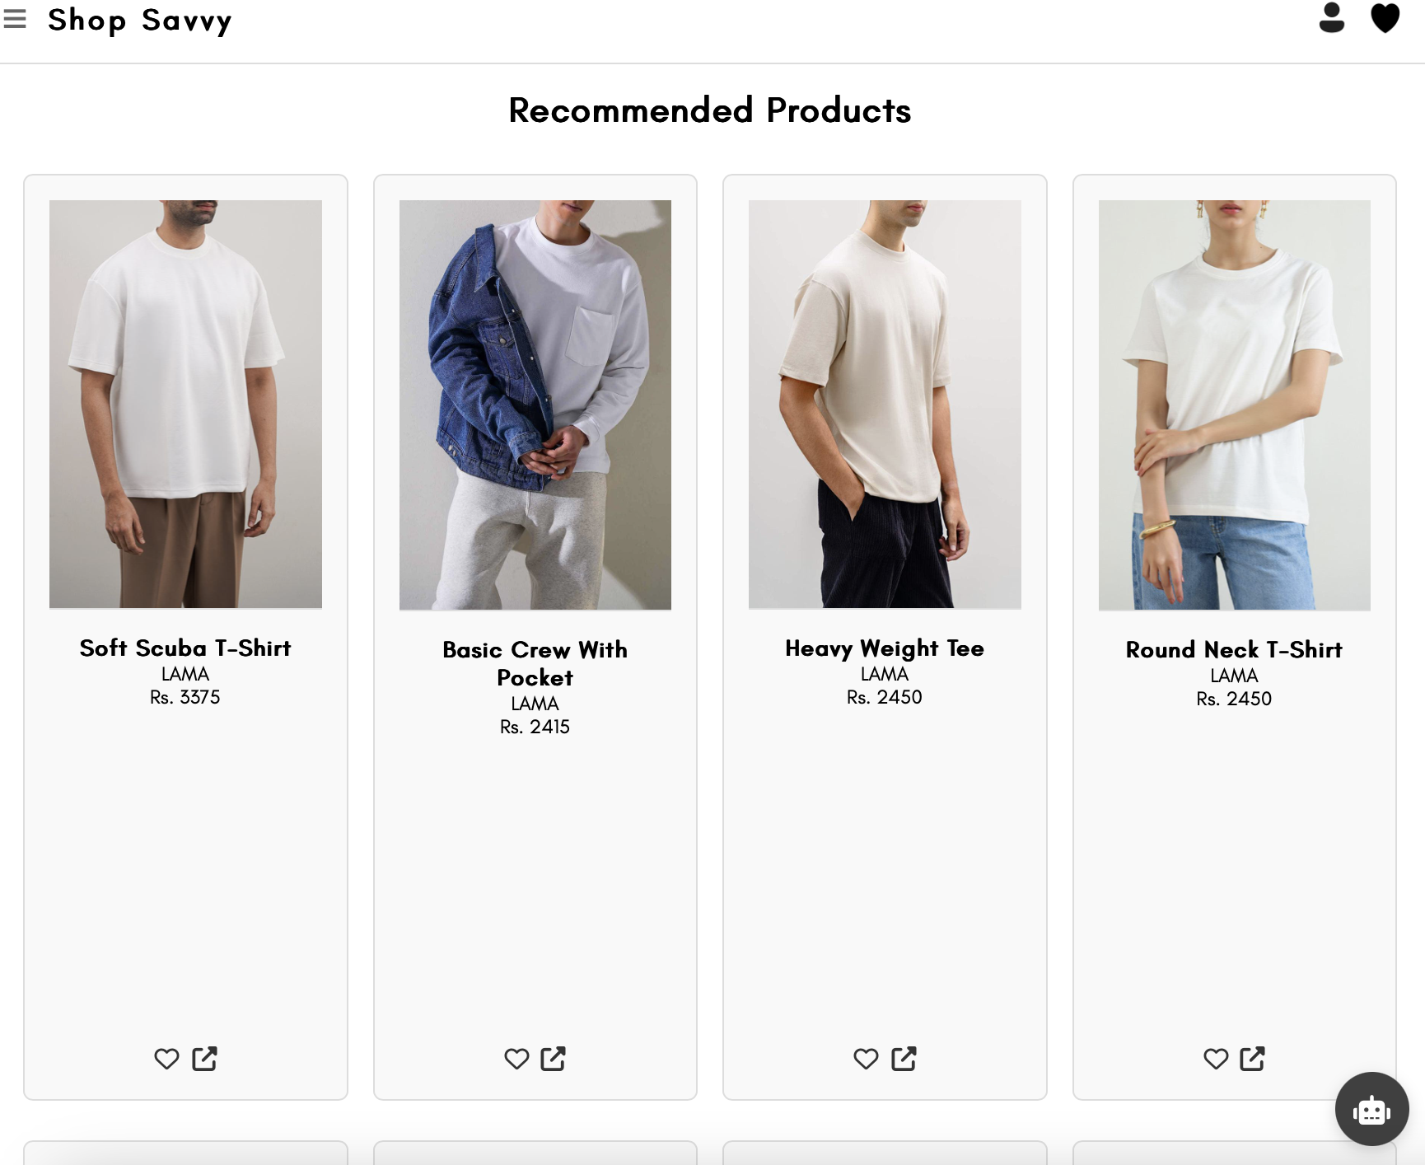

### **5. Navigation Bar**

The navigation bar allows quick access to product categories under:

* **Men:** T-shirts, Polos, Jeans, Trousers, etc.
* **Women:** Tops, Kurtas, Jeans, Trousers, etc.

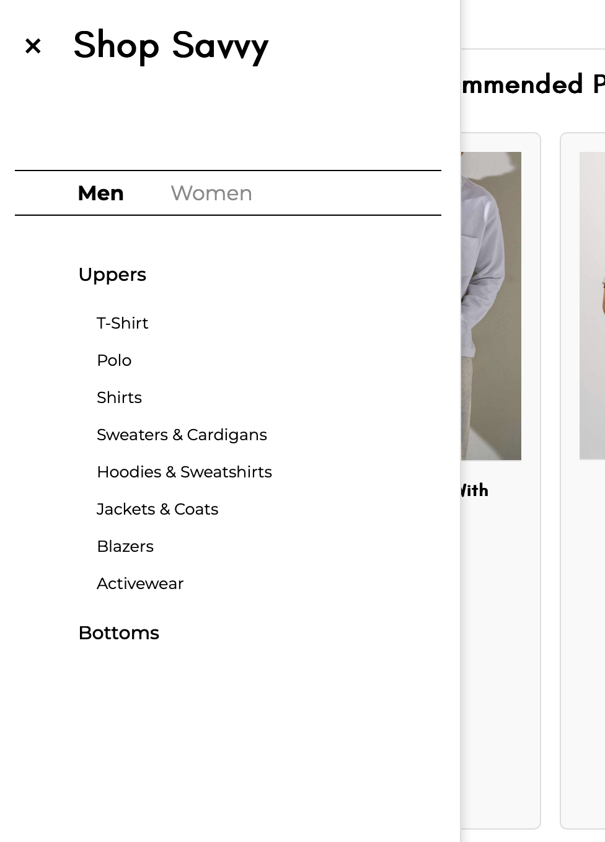

### **6. Category Page**

Each category page displays 20 products per page with options to:

* Navigate using **Next** and **Previous** buttons.
* View thumbnails, brief descriptions, and prices.

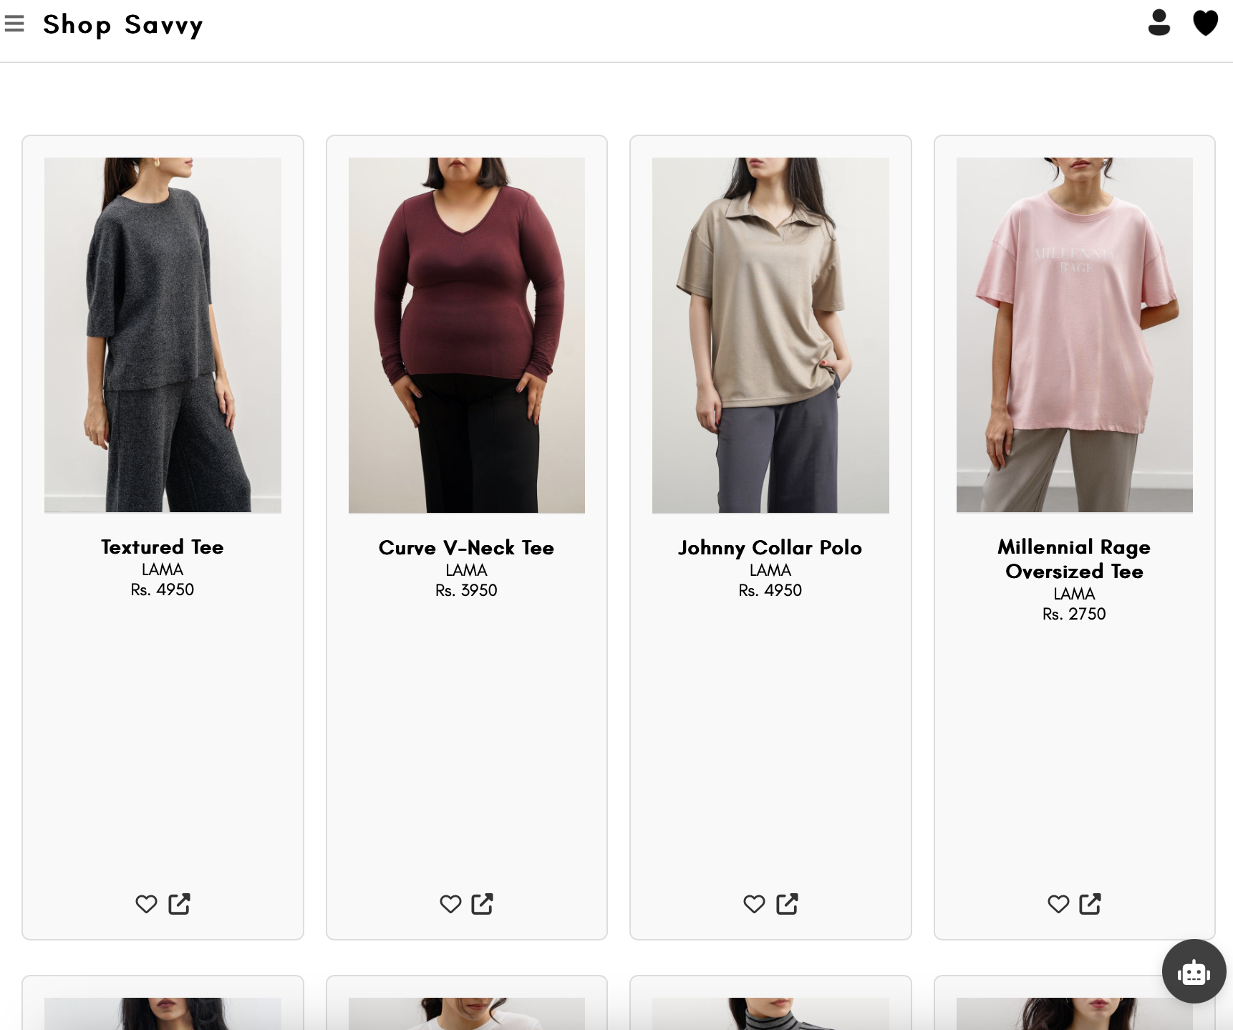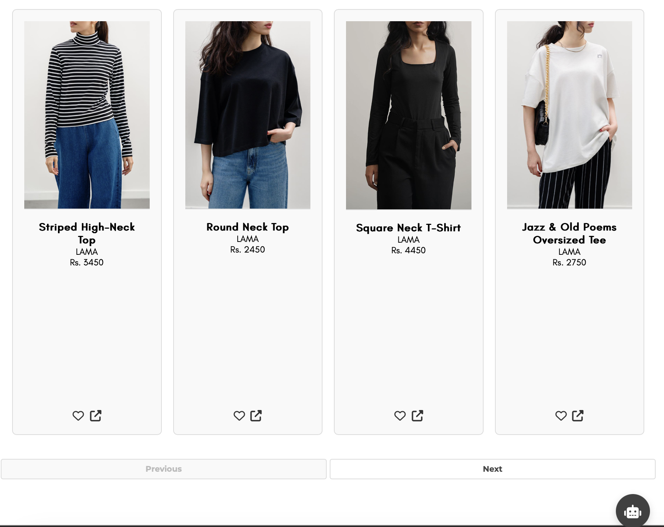

### **7. Filters Panel**

Users can refine their searches using dynamic filters including:

* **Color**, **Size**, **Brand**, **Price Range**
* **Sort By:** Price (low to high, high to low), Alphabetical order

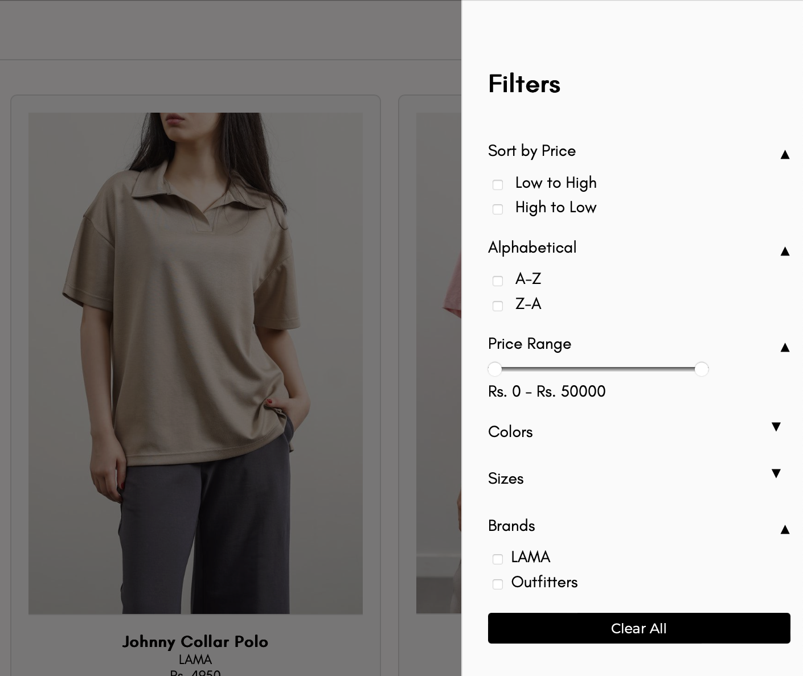

### **8. Product Detail Page**

Each product page includes:

* Name, brand, price, and description.
* A **redirection link** to the actual e-commerce platform.
* A **"Similar Products"** section to aid user exploration.

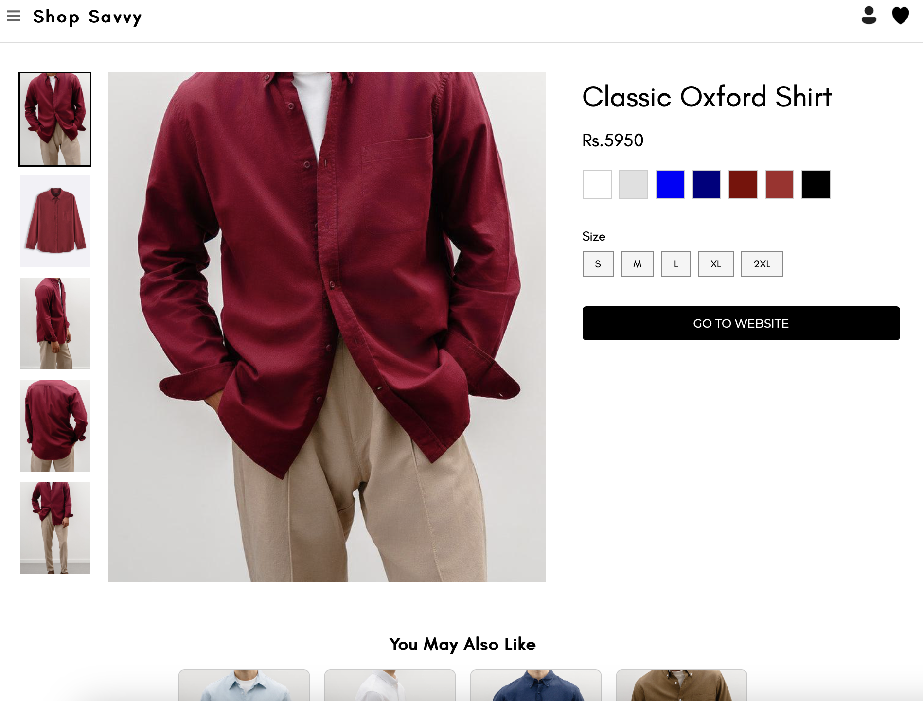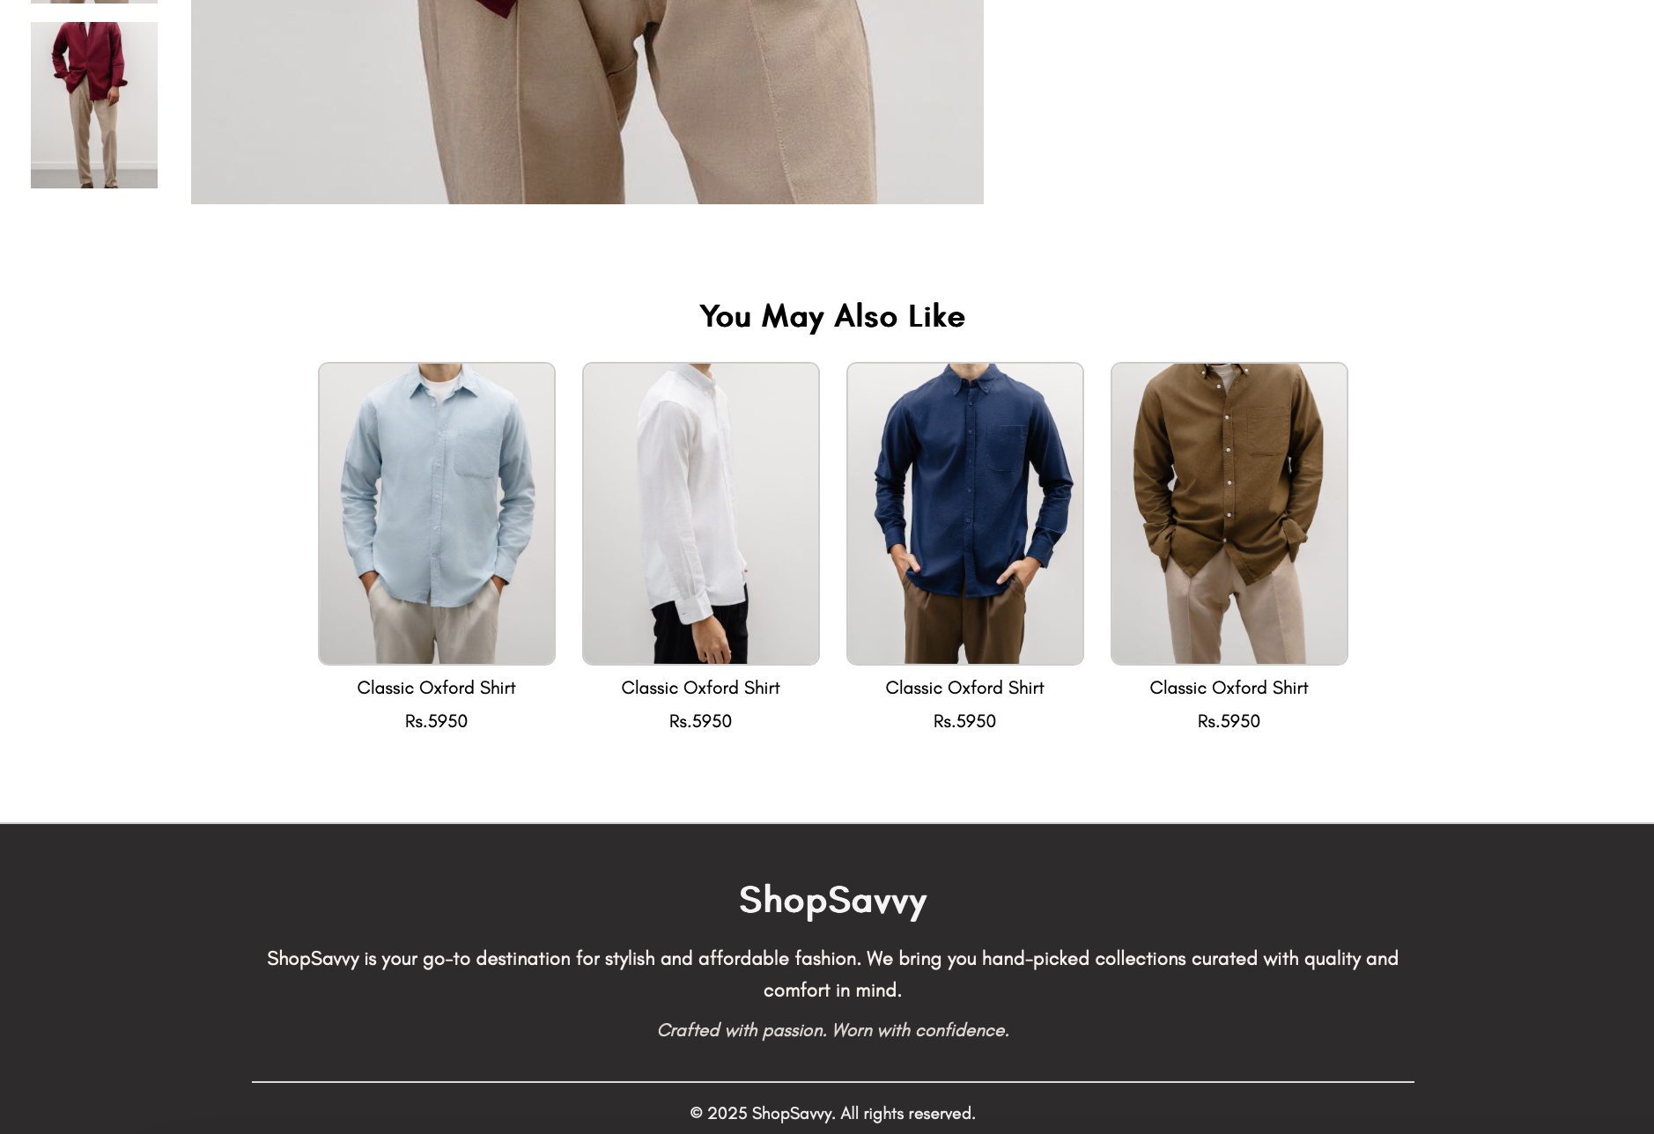

### **9. Wishlist Page**

Displays all the products wishlisted by the user. Users can view details or remove items from the wishlist.

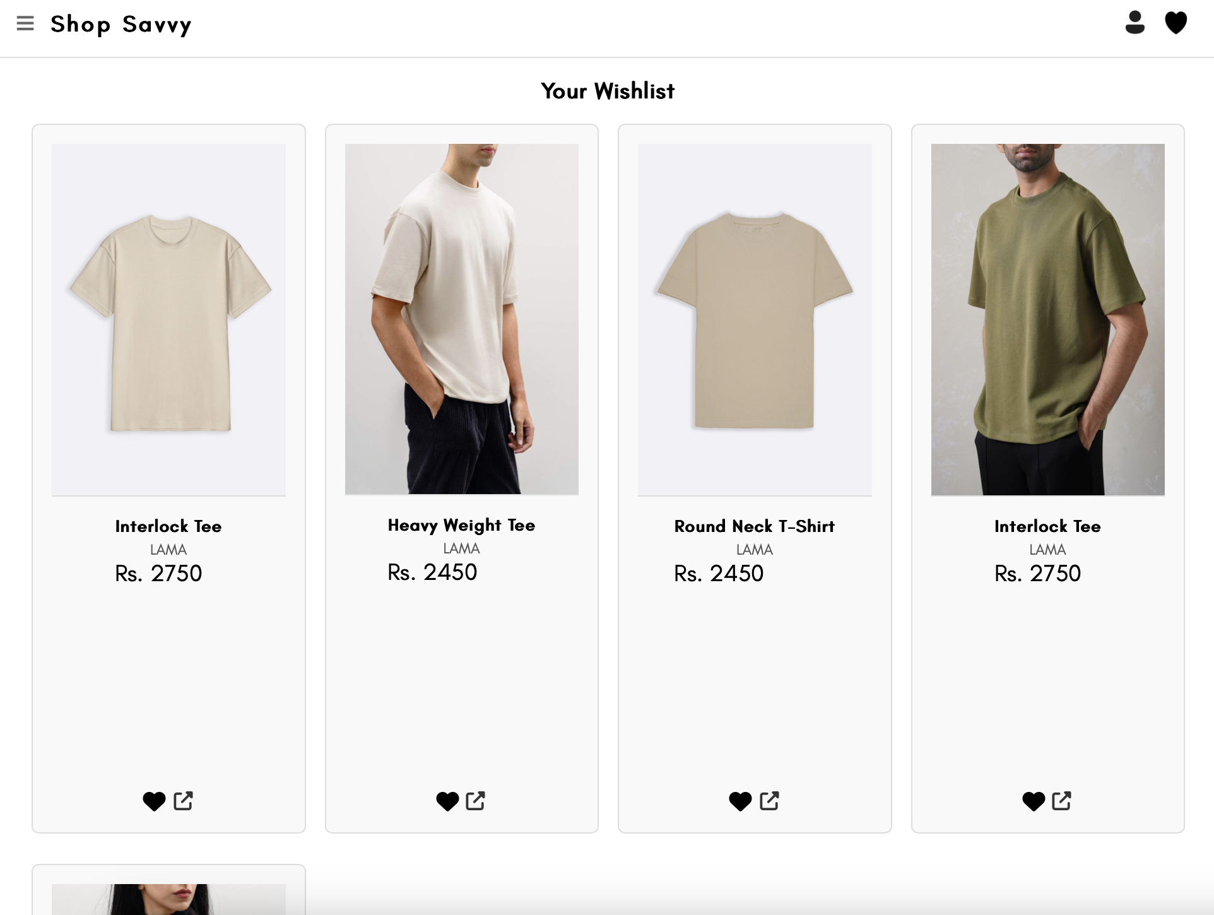

### **10. User Profile Page**

The profile page shows:

* User’s personal information (name, email)
* Option to update password.

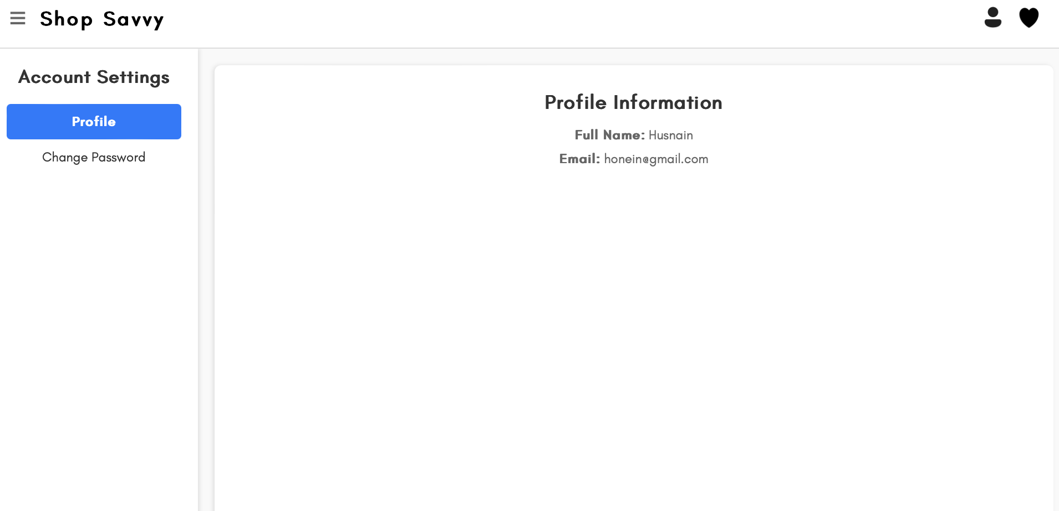

### **11. Chatbot Assistant**

An LLM-based chatbot assistant is integrated into the bottom-right corner of the application across most major pages. It provides real-time support by handling greetings, general queries, and fashion-related questions, intelligently distinguishing between them using natural language processing. The chatbot offers personalized assistance by storing previous conversation history, enabling it to provide more relevant suggestions over time. It can recommend products, suggest filters, guide users to specific categories or deals, and assist with navigation, delivering a tailored and interactive shopping experience.

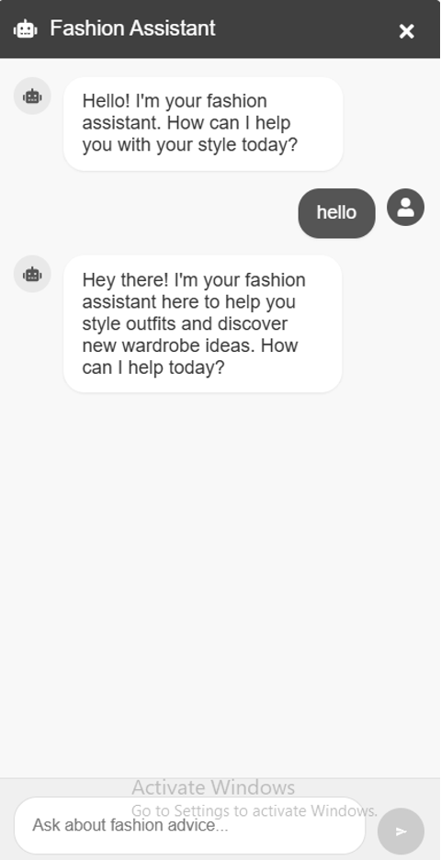

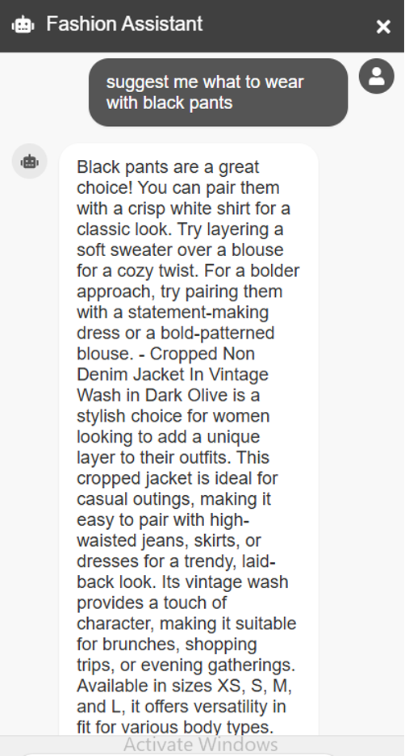

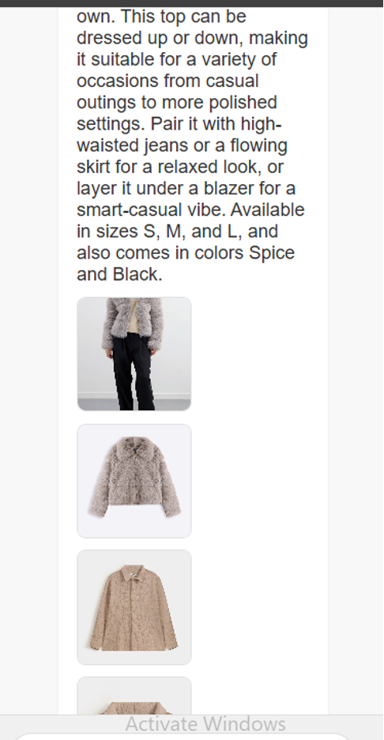

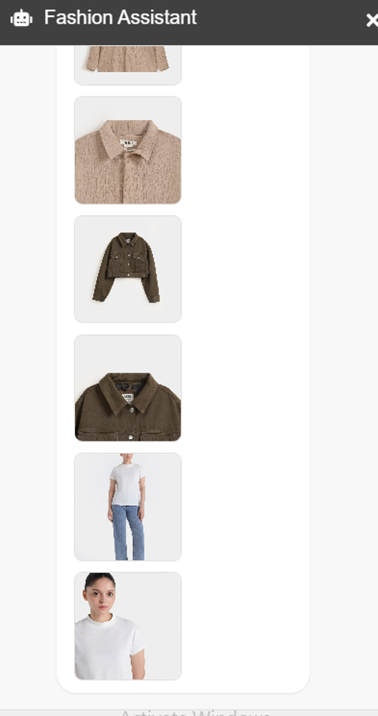

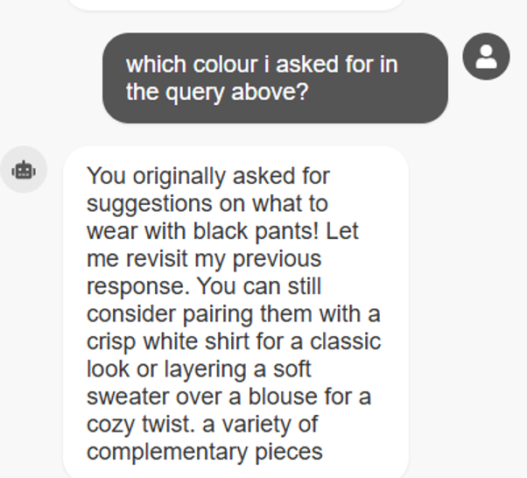

# Project Security

This section outlines the essential security considerations relevant to the Shop Savvy platform. Given the integration of user data, AI recommendation engines, real-time scraping, and interaction with third-party e-commerce platforms, security is a critical concern. Effective management of security threats and vulnerabilities ensures the confidentiality, integrity, and availability of the platform, protecting user trust and maintaining compliance with data protection standards.

## Project Threats

Shop Savvy faces several key security threats, primarily due to the sensitivity of user data, extensive integration with external platforms, and reliance on automated systems:

* **Data Breaches**: Sensitive user data such as emails, passwords, shopping history, and personal preferences stored in MongoDB could be compromised through unauthorized database access.
* **Injection Attacks**: Risks from SQL and NoSQL injections, particularly through the web application's interfaces, could lead to unauthorized data exposure or manipulation.
* **Cross-Site Scripting (XSS)**: Malicious scripts injected via product listings or user interactions could compromise the integrity of the frontend, exposing user sessions or sensitive data.
* **Unauthorized API Access**: APIs used to interact with e-commerce platforms and recommendation engines may become vulnerable to unauthorized use or data scraping.
* **Account Hijacking**: Weak authentication mechanisms could enable unauthorized access to user accounts.
* **Denial of Service (DoS/DDoS)**: Attacks targeting the backend infrastructure, potentially overwhelming servers and making the service inaccessible.

## Potential Losses

Each of these threats carries significant potential losses:

* **Financial Loss**: Breaches leading to compromised user data could result in financial penalties, loss of revenue due to disrupted services, and remediation costs.
* **Reputational Damage**: Security incidents can severely harm customer trust, resulting in loss of user base and competitive market positioning.
* **Legal and Compliance Issues**: Failure to adhere to regulations such as GDPR and CCPA could lead to litigation, heavy fines, and operational restrictions.
* **Operational Disruption**: DoS attacks and other malicious activities could severely affect service availability, reducing customer satisfaction and business continuity.

## Security Controls

To mitigate these identified threats, Shop Savvy will implement several key security controls categorized as follows:

* **Protective Controls**:
  + **JWT Authentication**: Use JSON Web Tokens (JWT) for secure, stateless authentication. This ensures that only authenticated users can access personalized features like recommendations, wishlists, and purchase history.
  + **Email Verification**: Implement email verification to ensure that users registering accounts provide valid email addresses, preventing unauthorized account creation and improving account security.
  + **Password Hashing**: Store passwords securely using bcrypt or a similar hashing algorithm to ensure that even in the case of a data breach, sensitive information remains protected.
  + **Secure HTTP Headers**: Use HTTP headers such as Content Security Policy (CSP) and HTTP Strict Transport Security (HSTS) to secure the frontend application and prevent attacks like XSS and man-in-the-middle.
  + **Rate Limiting**: Implement rate limiting on API requests to prevent abuse and mitigate brute-force attacks.

* **Detective Controls**:
  + **Basic Logging**: Keep logs of user activity such as login attempts, data access, and other significant actions to help detect suspicious behavior.
* **Recovery Controls**:
  + **Password Reset**: Implement a secure password reset functionality with multi-step verification, allowing users to regain access to their accounts if they forget their credentials.

Integrating these security measures significantly enhances the security posture of Shop Savvy, safeguarding user trust and ensuring compliance with best practices and regulatory standards.

# Risk Management

## Potential Risks and Mitigation Strategies Effective risk management is critical to the successful deployment and sustained operation of the Shop Savvy platform. Identifying potential risks proactively allows for strategic mitigation, reducing their impact on the project's objectives and ensuring smooth performance. The following table summarizes key potential risks along with concise mitigation strategies.

|  |  |  |
| --- | --- | --- |
| **Sr.** | **Risk Description** | **Mitigation Strategy** |
|  | Data Scraping Issues | Regularly monitor scraping scripts, maintain fallback methods, and promptly adjust to changes in website structures. |
|  | API Rate Limits and Outages | Implement caching strategies, fallback data handling, and establish communication protocols with partner platforms. |
|  | Recommendation Engine Performance | Continuously validate recommendations with user feedback, implement model retraining schedules, and regularly evaluate model accuracy metrics. |
|  | User Data Breach | Enforce robust encryption, strict access controls, multi-factor authentication, and routine security audits. |
|  | Compliance and Regulatory Risks | Regularly review and update privacy policies and data management practices to comply with GDPR and CCPA regulations. |
|  | System Scalability Issues | Employ load balancers, auto-scaling cloud resources, and thorough performance testing to handle increased user load smoothly. |
|  | Infrastructure Downtime | Use redundant hosting and database solutions, automated backups, and real-time system monitoring for rapid recovery. |
|  | Third-party Dependency Failure | Develop alternatives and maintain redundancy with multiple third-party service providers. |
|  | Security Vulnerabilities in Code | Conduct regular static (SAST) and dynamic (DAST) security testing, integrate secure coding standards, and perform ongoing developer security training. |
|  | User Adoption Challenges | Implement iterative UX testing, gather continuous user feedback, and maintain proactive customer support and engagement strategies. |

# Testing and Evaluation

**10.1.** **Functional Testing**

To ensure system reliability, each feature of *Shop Savvy* was rigorously tested using a combination of **manual exploratory testing** and **unit testing** (where applicable). Below is a breakdown of key modules tested:

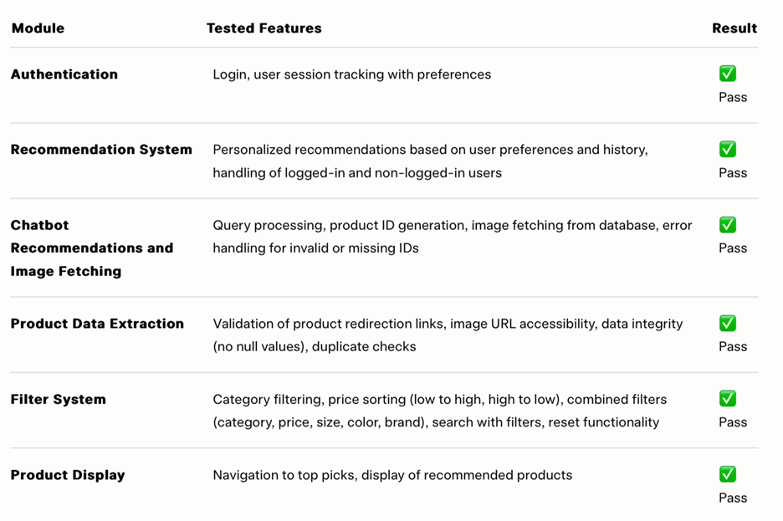

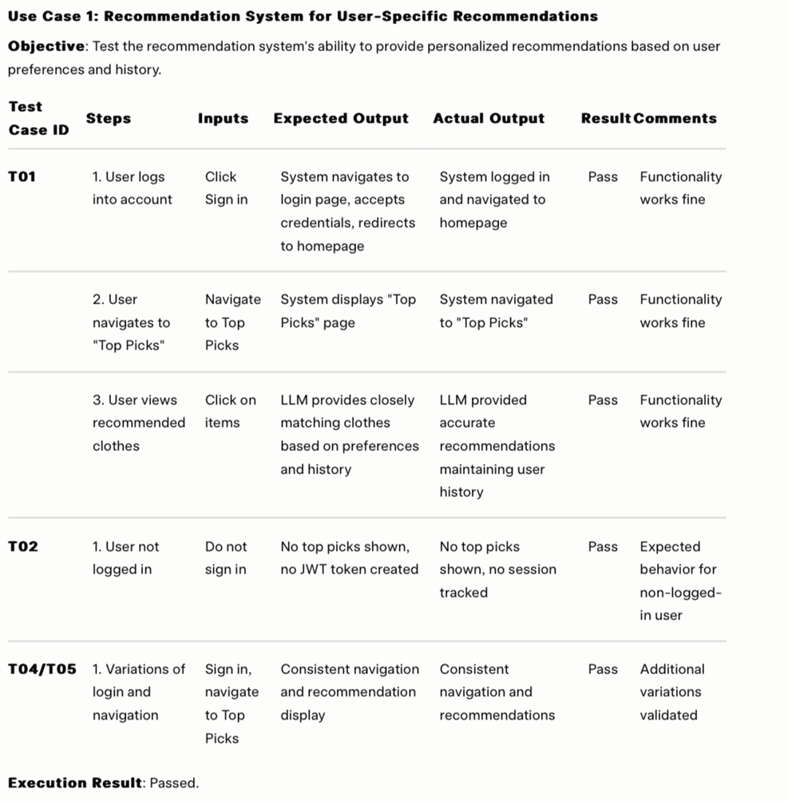

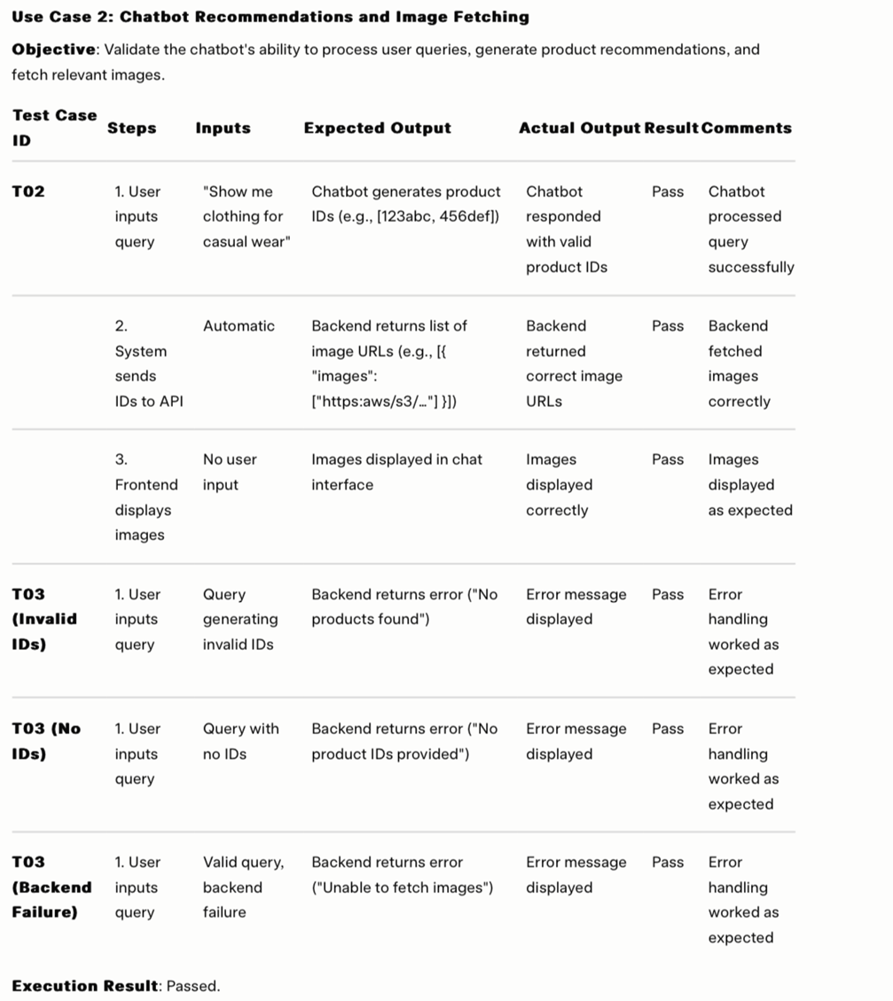

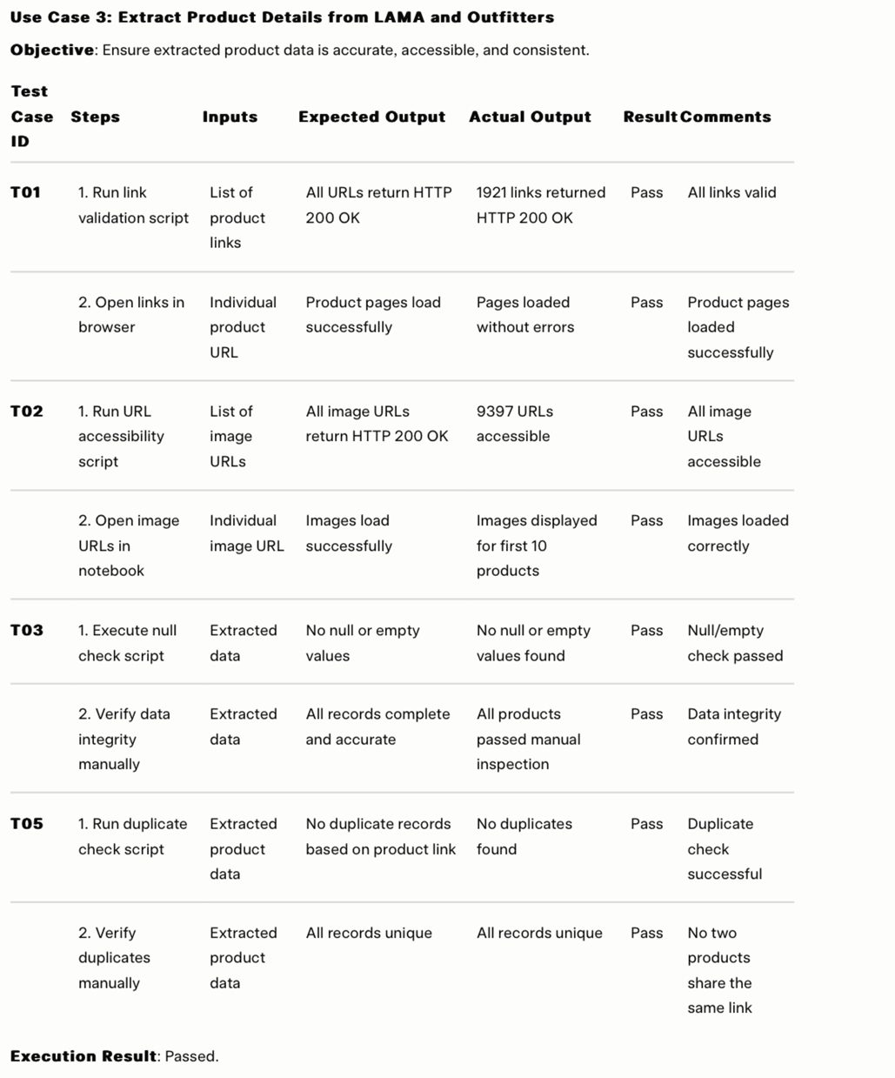

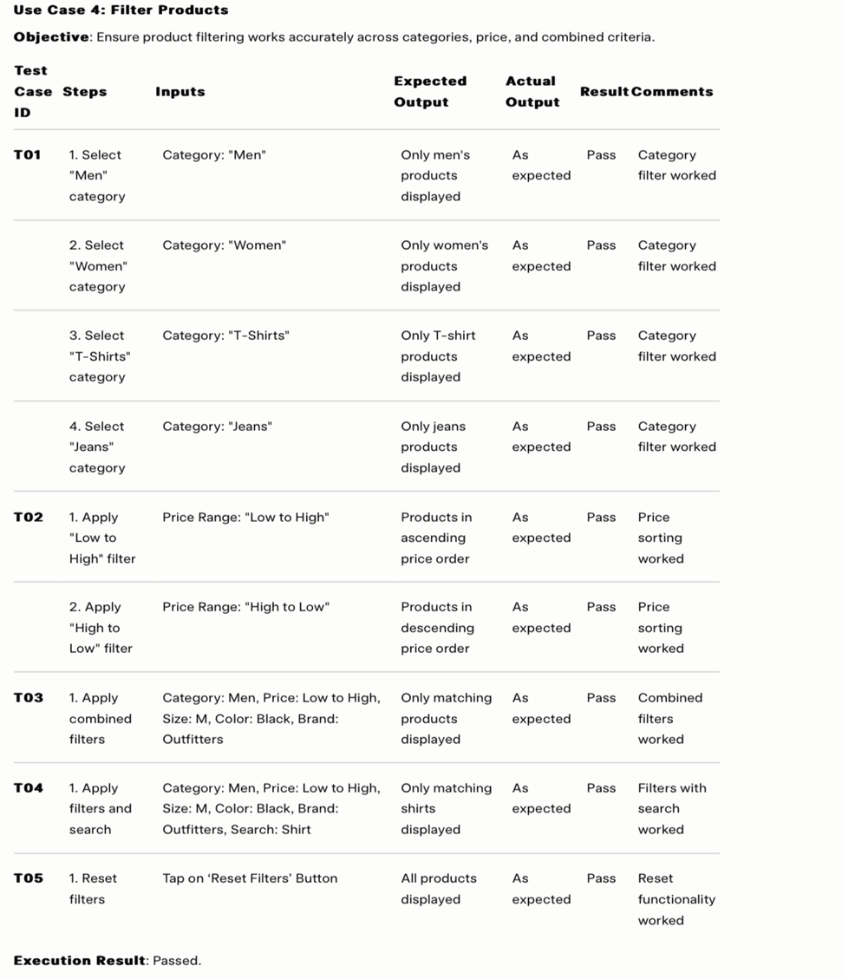

## **10.2.** **Performance Considerations**

Although *Shop Savvy* is an early-stage prototype, several steps were taken to ensure efficiency:

* **Frontend Optimization**:
  + Image components were loaded lazily.
  + Products were paginated (not rendered all at once).
  + State updates were minimized using React’s efficient re-render logic.
  + Image URLs were stored in MongoDB schemas instead of binary data, and the images were hosted on AWS S3 for faster, scalable delivery.
* **Backend Efficiency**:
  + Indexes were created in MongoDB for faster filter-based lookups.
  + The recommendation API computes scores on-the-fly using in-memory logic for active sessions.
* **Scraper Runtime**:
  + On average, scraping each brand took under 10 seconds per page.
  + Broken links and timeouts were logged, with retry logic where feasible.
* **API Response Times**:
  + Most backend endpoints responded under 300ms in local/staging environments.

# Deployment Guidelines

The *Shop Savvy* full-stack system was deployed using free-tier services to accommodate budget constraints. Below is an overview of the deployment setup, with each component explicitly detailed, followed by challenges encountered and their resolutions.

## **Deployment Setup**

* **Frontend**: Hosted on **Vercel** – leveraging globally distributed static assets for fast delivery of the user interface.
* **Backend**: Hosted on **Render** – hosting the core API endpoints for the application logic.
* **Chatbot**: Hosted on **Render** – powering the query processing and recommendation generation functionality.
* **Data Scraping**: Hosted on **Render** – managing the extraction of product details from LAMA and Outfitters.
* **Recommendation System**: Hosted on **Render** – handling personalized product suggestions based on user preferences and history.
* **Database**: **MongoDB Atlas** – utilized for cloud-based storage of product data, user preferences, and recommendation history.

**Deployment Challenges:**

* **CORS Issues**: The Vercel hosted frontend encountered blocked requests to the Render hosted backend, chatbot, data scraping, and recommendation system APIs due to Cross Origin Resource Sharing (CORS) restrictions.
  + **Solution**: Configured explicit CORS middleware on the Render hosted services to allow requests from the Vercel hosted frontend.
* **Free-Tier Cold Starts**: The Render free-tier services (backend, chatbot, data scraping, and recommendation system) exhibited slower response times for the first request after periods of inactivity, impacting initial user experience.
* **Frontend-Backend Sync Issues**: Mismatches in API versioning between the Vercel frontend and Render hosted backend, chatbot, and recommendation system caused occasional failures in responses.
  + **Solution**: Ensured consistent versioning across deployments and added automated checks to validate API compatibility before going live.

**Github Repo Link**:<https://github.com/zainabfatimaaa/Sproj_P14_Code.git>

**Depolyed Website Link:** [**https://sprojp14.vercel.app/**](https://sprojp14.vercel.app/)

# Conclusion

## Summary

The development of Shop Savvy has focused on addressing the inefficiencies within the current Pakistani fashion e-commerce landscape, leveraging AI and advanced technologies to enhance the online shopping experience. By integrating a robust recommendation engine, natural language processing (NLP)-powered chatbot, and real-time data from multiple e-commerce platforms, the project offers personalized and seamless shopping assistance. Through the use of the MERN stack and Agile methodology, the project successfully navigated dynamic requirements and technical challenges, ultimately delivering a responsive and scalable web application.

## Challenges

During the development of Shop Savvy, both technical and non-technical challenges arose, which were tackled through strategic planning and innovative solutions:

1. **API Limitations and Latency**: One of the major hurdles was managing the integration of various third-party APIs for product data and chatbot functionalities. Ensuring that the system handled API rate limits and prevented lag in delivering real-time recommendations proved to be challenging. To address this, we implemented caching strategies and fallback methods, allowing the system to continue delivering a smooth experience even when external APIs faced issues.
2. **Chatbot Integration Without a Custom Trained LLM**: Forming an effective recommendation pipeline without a custom-trained language model was another challenge. Utilizing third-party APIs such as Hugging Face's pre-trained models posed limitations in providing truly context-aware, store-specific recommendations. Developing a system that could give users product-aware suggestions, factoring in real-time inventory and contextual details from various stores, required significant fine-tuning. Despite these limitations, we integrated LLMs effectively through API-driven approaches to provide relevant conversational support to users.
3. **Data Scraping and Real-time Stock Updates**: Web scraping, a core part of aggregating fashion products from multiple brands, was complex and resource-intensive. Managing scraped data while ensuring that it stayed up-to-date with the frequent stock changes was challenging. To mitigate this, we developed a robust system that frequently checks for stock updates and integrates real-time data into the platform.
4. **Maintaining Scalability**: Handling high traffic volumes, particularly during peak shopping seasons, while ensuring no degradation in performance was a technical challenge. Using cloud-based auto-scaling solutions and employing load-balancing strategies helped us address potential bottlenecks, ensuring that the platform could scale effectively.
5. **User Experience Design**: One of the non-technical challenges was ensuring a user-friendly interface that was intuitive and aesthetically appealing. Feedback from initial user testing was critical in refining the interface and ensuring ease of navigation across a wide range of products and filters.

## Future

The Shop Savvy platform holds significant potential for future growth and expansion:

1. **Integration of More Stores**: Expanding the platform to include a broader range of local and international fashion retailers will provide users with a wider variety of products, making Shop Savvy a one-stop-shop for fashion.
2. **Enhanced Recommendations and AI Models**: Future improvements will include training a custom recommendation engine using more advanced machine learning models. This will allow the platform to offer even more personalized and accurate suggestions based on individual user behavior, preferences, and fashion trends.
3. **Image and NLP-based Search**: Extending the search functionality to include image-based searches and advanced NLP will further enhance user experience. Users will be able to upload images of fashion items they like, and the system will recommend similar products from various platforms, creating a more immersive shopping experience.
4. **Direct Shopping Integrations with Brands**: Future versions of Shop Savvy could establish partnerships with fashion retailers for direct shopping capabilities. This integration would allow users to complete their purchases without leaving the platform, further streamlining the shopping process and providing a more cohesive user journey.
5. **Personalized Virtual Shopping Assistant**: A future version could feature a fully integrated, AI-powered shopping assistant capable of guiding users through their fashion journey, offering personalized style advice, suggesting complete outfits, and even helping with budget-conscious shopping decisions.

By implementing these features, Shop Savvy can further revolutionize the fashion e-commerce landscape, expand its reach and offer enhanced value to users.

# Review checklist

Before submission of this report, the team must perform an internal review. Each team member will review one or more sections of the deliverable.

|  |  |
| --- | --- |
| **Chapter/Section Name** | **Reviewer Name(s)** |
| 2,3 | Ahmed Kashif Jabbar |
| 4 | Husnain Ali |
| 6,10,11 | Musa Aftab Ahmed |
| 5,7 | Syed Meesum Ali |
| 1,8,9,12 | Zainab Fatima |

# References